

NU FAIRVIEW

School of Engineering and Technology

Bachelor of Science in Information Technology

with Specialization in Mobile and Internet Technology

MOTO: Mobile Operations and Tricycle Organizer for Cielito Cristina Castle Spring Heights TODA Efficiency

Project Documentation Submitted to the Faculty of

Bachelor of Science in Information Technology

In Partial Fulfillment of the Requirements for

PROJMAN – Project Management

By:

Benito, Djanairah M.

Capawing, Eulan Miguel V.

Choa, Jerycho Roniel I.

Zamodio, Ken Aixroch A.

November 2025
Table of Contents
1.0 Company Profile 3
2.0 Business Case 3
2.1 Problem Definition 4
2.2 Project Overview 6
2.3 Strategic Alignment 11
2.4 Cost and Benefit Analysis 11
3.0 Project Charter 15
3.1 Project Purpose / Justification 15
3.1.1 Business Need 15
3.1.2 Business Objective 16
3.2 Project Description 17
3.3 Risks 25
3.4 Project Key Deliverables 27
3.5 Summary Milestone Schedule 28
3.6 Budget Summary 28
3.7 Project Approval Requirements 29
4.0 Project Management Approach 31
5.0 Project Technical Approach 35
5.1 Product Development Methodology 36
5.2 Technical Architecture 37
6.0 Project Management Plans 39
6.1 Stakeholders Strategy Management Plan 40
6.2 Scope Management Plan 42
6.3 Cost Management Plan 44
6.4 Schedule Management Plan 47
6.5 Staffing Management Plan 52
6.6 Change Management Plan 54
6.7 Communications Management Plan 57
6.8 Quality Management Plan 59
6.9 Risk Management Plan 61
6.10 Procurement Management Plan 66
6.11 Implementation Plan 69
7.0 Sponsor Acceptance 72
8.0 Appendices 78
References 78

1.0 Company Profile
The Cielito Cristina Castle Spring Heights Tricycle Operators and Drivers Association (CCCH TODA) is a local transport service organization based in Cielito Homes Barangay 177 in Caloocan City. With a fleet of approximately 25–68 active tricycle units, the association serves an estimated 200 passengers daily, providing reliable and affordable transportation within the community.
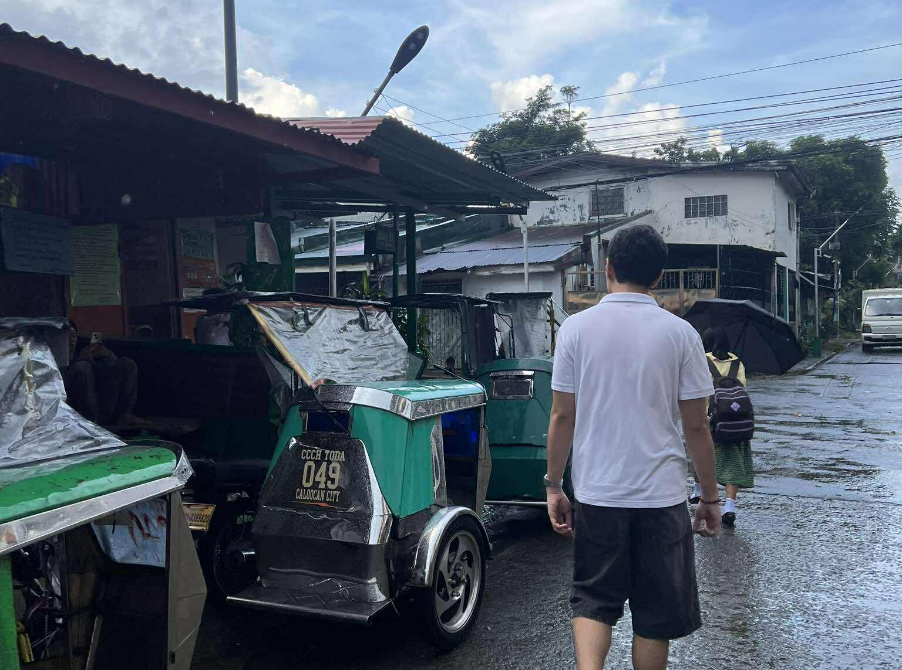

Figure 1. Cielito Homes Tricycle Station
CCCH TODA operates under a membership system where drivers contribute a ₱5 every ride butaw (operational fee), with free butaw on Saturdays and Sundays. The association’s core focus is to deliver accessible, fair, and community-centered transport services, while also promoting accountability and cooperation among its members. With growing commuter demand, CCCH TODA is open to modernization efforts that will improve operational efficiency, transparency, and passenger satisfaction.

2.0 Business Case
The MOTO (Mobile Operations and Tricycle Organizer) initiative aims to end the inefficiencies and organizational issues experienced by most TODA (Tricycle Operators and Drivers' Associations). Currently, most TODA organizations considerably depend on manual systems for driver scheduling, fare collection, and route allocation. These traditional processes commonly lead to poor coordination, lost revenue opportunities, driver conflicts, and lack of transparency.
This project is to consolidate TODA operations in a centralized and mobile-enabled platform which could digitize and automate tasks daily. With this, it would enhance driver responsibility, improve passenger service, and give leadership accurate information for decision-making.

2.1 Problem Definition
This section includes the following issues currently faced within the institution and their desired results to solve the problem with possible proposed solution.

2.1.1 Problem Statement
Many TODA groups still use manual systems for contribution monitoring, fare tracking, and a lack of transparency. These outdated methods make it hard to manage operations and limit opportunities for growth and accountability. To solve this, the project proposes MOTO, a mobile platform that automates contribution monitoring, driver queuing, digitizes fare monitoring, and improves communication, helping TODA operate more efficiently and effectively.
CCCH TODA currently faces operational challenges due to its reliance on traditional systems for the existing traditional contribution (butaw) system (₱5 every ride) is manually managed as their way of paying their contribution is by extending or accepting with hand, making it prone to errors, lack of transparency and security. These inefficiencies negatively affect both the drivers who may feel disadvantaged in the queuing system or unsure about contributions and the passengers, whose satisfaction declines due to long waits and poor accessibility.
At the terminals, passengers experience long waiting times and have limited means of direct communication outside of face-to-face interaction which can leads to inconvenience during booking issues, delays, or location mismatches, especially during peak hours or in areas with less fare monitoring. With approximately 200 commuters relying daily on CCCH TODA’s services and often resort to roaming around to find available tricycles, which leads to disorderly boarding. These issues not only reduce operational efficiency but also hinder the association’s ability to modernize and maintain competitiveness in the growing demand for organized and technology-driven transport solutions. This situation becomes even more difficult during unfavorable weather conditions such as heavy rain or extreme heat, forcing passengers to go to the terminal instead of conveniently booking a ride.

2.1.2 Organizational Impact
The current operations of CCCH TODA face several challenges that directly affect both contribution management and income generation. In terms of operations, the manual ₱5 every ride butaw system relies on physical cash handovers, making it prone to errors, lack of transparency, and security concerns. This creates mistrust and uncertainty among drivers regarding how contributions are recorded and managed. Financially, inconsistent fare tracking and limited passenger bookings reduce driver earnings, making it harder for them to consistently meet their contribution obligations. For drivers, uneven trip distribution and the absence of a structured booking system result in unfairness in income opportunities, further discouraging timely contributions. Passengers also experience long waiting times and inconvenience due to the lack of a booking platform, which affects satisfaction and reduces potential ridership.
Overall, these issues lead to missed contribution payments, decreased income opportunities, and reduced competitiveness of the TODA. By digitizing contribution monitoring and introducing a mobile booking system, CCCH TODA can ensure more transparent butaw collection while helping drivers secure higher and more consistent income to sustain daily contributions.

2.2 Project Overview
The MOTO: Mobile Operations and Tricycle Organizer is a digitalization initiative for CCCH TODA in Barangay 177. It combines IoT hardware and mobile technology to improve booking management, contribution tracking, and transparency:
- Digital Contribution Tracker (Smart Piggy Bank): An RFID-enabled device with an LCD display that allows tricycle drivers to log and monitor their daily butaw contributions digitally. Each transaction is automatically recorded and synchronized with the operator’s dashboard and mobile app.
- RFID Assignment System: A dedicated RFID scanner used by the admin to assign RFID cards to verified drivers. After registration, drivers are required to upload their Driver’s ID and necessary documents for verification. Once approved, they must visit the TODA station to receive their assigned RFID card. RFID registration is now handled solely by the admin for security and accountability.
- Queue Management and Display: Drivers can view their real-time queue position and receive notifications when it is their turn, ensuring fair and organized dispatching. If a booking remains unaccepted for a certain period, the system will automatically cancel or retry the request.
- Barker Mobile App: A dedicated app for barkers to handle on-site or walk-in passengers. Barkers can group up to four (4) passengers per tricycle if they share the same destination. Once the booking is confirmed, the system automatically assigns the next available driver from the queue.
- Passenger Mobile App: Supports user registration, ride booking, fare estimation, contribution tracking visibility, live trip updates, and in-app chat with drivers. Passengers can also upload valid Student, Senior Citizen, or PWD IDs to apply for a 20% fare discount and exemption from the ₱2 convenience fee for online bookings. Admins verify all uploaded IDs to confirm discount eligibility.
- Driver Mobile App: Allows drivers to receive both on-site and online bookings, view queue positions, trip history, and contributions. New features include a Contributions Tab for post-ride payments, an RFID Tab for reporting lost RFID cards, document upload for registration verification, and status feedback (pending, approved, or requires revision).
- Admin Web Dashboard: A centralized web application that enables TODA officials to manage and monitor the entire system. Admins can oversee bookings, queues, and contributions, verify passenger discount applications and driver documents, configure fare matrix settings, and review system activities through the Audit Log. The admin is also responsible for assigning RFID cards to verified drivers.
- Account Management and Security: Includes phone verification to prevent duplicate or fraudulent accounts and a Forgot Password feature for both drivers and passengers to recover their credentials securely.
The system directly addresses TODA challenges such as manual contribution tracking, lack of transparency, and disorganized passenger dispatching. By digitizing these processes, it ensures fairer booking distribution, boosts driver income opportunities, enhances passenger experience, and supports TODA’s transition to accountable and transparent digital operations.
Time-bound
The project will be developed and deployed within four (4) months of 1st term of academic capstone cycle (July 2025 – October 2025), with the following milestones:
- Prototype Development – July to August 2025
- Pilot Testing – August to September 2025
- Evaluation and Refinement – September to October 2025
- Final Implementation & Turnover – Year 2026
In Scope:
- Mobile Application Development
  - Passenger Booking System: Allows passengers to book tricycle rides through the mobile app, view estimated fares, track live ride updates, and rate drivers after trips. Bookings can be made through Online Booking (app-based) or Onsite Booking/Walk-in handled by barkers at the TODA station.
  - Driver-Side App: Enables drivers to receive both on-site and online bookings, view queue positions, manage trip history, and monitor contribution records. Includes document upload during registration and feedback notifications on verification status (pending, approved, or for revision).
  - Fare Estimation and Discounts: Calculates fares starting at ₱25 for the first kilometer and ₱5 for each succeeding kilometer, with a ₱2 convenience fee for online bookings. Students, senior citizens, and PWDs receive a 20% discount and are exempted from the convenience fee after uploading valid ID proof for admin verification.
  - Contribution Tracking: Integrated with the RFID Smart Piggy Bank to record daily butaw contributions. Drivers can now contribute after each ride, and the system flags accounts with missed contributions.
  - Transaction Monitoring: Displays detailed daily records of trips, fares, and contributions for both drivers and admins.
  - Barker Application: A mobile app for barkers that allows them to process walk-in passengers and group up to four (4) passengers per tricycle with the same destination. Once booked, the system automatically assigns an available driver from the queue.
  - Chat Support System: Provides in-app chat between passengers and drivers during active bookings for better communication.
  - GPS Tracking: Tracks active tricycle routes and provides real-time location updates to both passengers and admins.
  - Booking Radius Restriction: Limits booking destinations to a 1.5 km radius from Barangay 177 for manageable and localized service coverage.
  - Account Management and Security: Includes phone verification, Forgot Password functionality for both drivers and passengers, and role-based access for users and admins.
- IoT Hardware Integration
  - RFID-Based Smart Piggy Bank: Installed at the TODA station to allow drivers to log butaw contributions digitally via RFID tap, with confirmation displayed on the LCD screen.
  - RFID Assignment Scanner: Used by the admin to assign RFID cards to verified drivers. After registration and document verification, the driver visits the TODA office to receive the RFID card personally. RFID registration is no longer handled by the driver.
- Web Application (Admin Dashboard)
  - Provides a centralized control system for monitoring bookings, queue activity, contributions, and discount applications.
  - Enables the admin to manage driver and passenger accounts, verify uploaded documents and IDs, configure the fare matrix, assign RFID cards, and review activities through the Audit Log for transparency.
Out of Scope:
  - Expansion or integration with other TODAs or barangays outside Barangay 177.
  - Booking requests beyond the 1.5 km radius service limit.
  - Development of digital payment systems (e.g., GCash, Maya, credit cards); all transactions remain cash-based, with the ₱2 convenience fee temporarily remitted through the tricycle association.
  - Hardware maintenance or component replacement beyond the initial setup phase (future maintenance will be handled by the TODA organization).
  - Tricycle drivers who are patrolling or operating outside the designated TODA station (“rumoronda”) are not covered or controlled by the system, as their activities are beyond MOTO’s monitoring scope.
  - RFID registration or reassignment performed by drivers this process is handled exclusively by the admin.
This structure ensures clear task allocation, efficient project tracking, and alignment with the project’s objectives and scope.

Table: 1 Work Breakdown Structure
WBS Code | Milestone | Start Date
1 | Project Planning | July 30 – August 3, 2025
1.1 | Stakeholder Management | July 31, 2025
1.2 | Scope Management | August 3, 2025
2 | Project Initialization | August 4 – August 21, 2025
2.1 | Cost Management | August 7, 2025
2.2 | Schedule Management | August 10, 2025
2.3 | Staffing Management | August 10, 2025
2.4 | Communication Management | August 10, 2025
2.5 | Change Management | August 14, 2025
2.6 | Quality Management | August 18, 2025
3 | Project Finalization | August 22– August 27, 2025
3.1 | Risk Management | August 22, 2025
3.2 | Procurement Management | August 25, 2025
3.3 | Project Final Documentation | August 27, 2025
4 | Project Documentation | August 28 – August 30, 2025
5 | System Design | August 31 – September 4, 2025
5.1 | UI/UX and Circuit Layout Design | September 1, 2025
6.1 | System Development | September 5– October 1, 2025
6.1 | Software Development | September 5, 2025
6.2 | Hardware Development | September 5, 2025
6.3 | Component Prototype | September 25, 2025
7 | System Testing | October 2 – October 15, 2025
7.1 | Testing of the System | October 2, 2025
7.2 | Data Gathering Analysis | October 8, 2025
7.3 | Calibrating Modules | October 12, 2025
8 | System Optimization | October 16 – October 21, 2025
8.1 | Feedback Implementation | October 16, 2025
8.2 | Quality Assurance | October 19, 2025
8.3 | Stakeholder Training | October 21, 2025
9 | System Deployment | October 22 – October 28, 2025
9.1 | Piggy Bank Installation | October 22, 2025
9.2 | MOTO System | October 25, 2025
9.3 | Staff Training | October 27, 2025
10 | Project Closure | October 29 – October 31, 2025
10.1 | Final-Launch Support | October 29, 2025

2.3 Strategic Alignment
The Cielito Homes Tricycle Operators and Drivers Association (CCCH TODA) in Barangay 177 is committed to providing accessible, reliable, and community-oriented transportation services. Its mission is to uphold fairness, transparency, and sustainability in tricycle operations while promoting cooperation and financial accountability among its members. The MOTO: Mobile Operations and Tricycle Organizer project directly supports this mission by modernizing key TODA processes such as driver verification, contribution management, and passenger booking — all of which were traditionally done manually through paper-based records.
Through the RFID-enabled Smart Piggy Bank with an LCD display installed at the CCCH TODA station, verified drivers can securely log their daily butaw contributions using their assigned RFID cards. Each transaction is automatically recorded and synchronized with the admin dashboard for accurate monitoring. Drivers now have the flexibility to contribute butaw after completing rides, allowing them to earn before depositing. The system automatically detects and flags drivers who fail to make their contributions after trips. Once a contribution is logged and confirmed, it is considered final and non-refundable, ensuring transparency, accountability, and fairness in operations.
To ensure that only verified members participate in the system, drivers are required to upload valid documents such as their Driver’s ID during registration. The admin then reviews and verifies the submission before assigning an RFID card through the RFID Assignment Scanner. RFID assignment is managed exclusively by the admin, and drivers physically receive their RFID cards at the TODA office upon approval.
For passengers, the MOTO Mobile App offers convenience and accessibility. They can easily book tricycle rides digitally, view fare estimates, communicate with drivers through in-app chat, and track their trips in real time. App-based rides are now referred to as Online Bookings, which include a ₱2 convenience fee. On-site transactions at the TODA station, handled by barkers, are called Onsite Bookings or Walk-ins. Students, senior citizens, and PWDs receive a 20% fare discount and are exempted from the convenience fee upon submission of valid identification. Uploaded discount IDs are verified by the admin through the web dashboard before approval.
Additionally, barkers play an important role in facilitating on-site operations through their dedicated Barker App, which allows them to record walk-in passengers and group up to four (4) individuals per tricycle for shared rides to similar destinations. This enhances booking efficiency and ensures equitable dispatching among drivers in the queue.
In the long term, MOTO strengthens CCCH TODA’s financial management, improves operational transparency, and enhances passenger satisfaction through organized and accountable operations. The system also empowers administrators with full oversight using the Admin Web Dashboard, where they can monitor bookings, queues, contributions, and fare compliance while maintaining a detailed audit trail of activities. Beyond efficiency, MOTO positions CCCH TODA as a technology-driven transport organization that embraces digital transformation while promoting inclusive, transparent, and sustainable community development.
Cost and Benefit Analysis
The development cost for this project includes the software, hardware, miscellaneous, and contingency fee is 382,519.00 PHP. Part of the estimated cost for employees is sourced from Indeed Philippines website.
2.4.1 Cost:

Table 2. Cost Analysis
Category | Item | Unit Price | Quantity | Estimated Cost (PHP)
Labor | Project Manager | ₱38,000.00 | 3 months | ₱105,000.00
Labor | Software Developer | ₱35,000.00 | 2 months | ₱76,000.00
Labor | Hardware Engineer | ₱28,000.00 | 2 months | ₱56,000.00
Labor | UI/UX Designer | ₱3,000.00 | 20 days | ₱60,000.00
Labor | QA Tester | ₱2,500.00 | 30 days | ₱75,000.00
Labor | Subtotal Labor Cost |  |  | ₱372,000.00
Hardware | Allan Universal Coin Slot | ₱500.00 | 1 set | ₱500.00
Hardware | Soldering Kit | ₱360.00 | 1 set | ₱360.00
Hardware | ESP32 Development Board | ₱350.00 | 1 pc | ₱350.00
Hardware | Arduino Uno | ₱300.00 | 1 pc | ₱300.00
Hardware | PN532 RFID Reader + 3 pcs Cards | ₱300.00 | 1 set | ₱300.00
Hardware | 16x2 LCD Display | ₱150.00 | 1 pc | ₱150.00
Hardware | RC522 RFID Reader and Scanner | ₱130.00 | 1 pc | ₱130.00
Hardware | LM2596 DC-DC Module | ₱95.00 | 1 pc | ₱95.00
Hardware | Bread Board 800 Pins | ₱60.00 | 1 pc | ₱60.00
Hardware | Jumper Wires (40 pcs) | ₱50.00 | 1 set | ₱50.00
Hardware | Power Switch | ₱49.00 | 1 pc | ₱49.00
Hardware | MB102 Breadboard Power Supply | ₱49.00 | 1 pc | ₱49.00
Hardware | Plywood 6x14 | ₱38.00 | 1 set | ₱38.00
 | Subtotal Hardware Cost |  |  | ₱2,431.00
Software | Realtime Database, Cloud Hosting, and Cloud Storage | ₱310.00/month | 1 year | ₱3,720.00
Software | Design Tools (Figma and Canva) | ₱0.00 | Free Tier | ₱0.00
Software | Development Platform (Android Studio and Arduino IDE) | ₱0.00 | Free Tier | ₱0.00
Software | Subtotal Software Cost |  |  | ₱3,720.00
Training & Documents | User Manuals | ₱12.00 | 70 pcs | ₱840.00
Training & Documents | Training Materials | ₱152.00 | 5 pcs | ₱760.00
Training & Documents | Document Printing | ₱500.00 | 1 set | ₱500.00
Training & Documents | Glossy Sticker Paper | ₱78.00 | 1 set | ₱78.00
Training & Documents | ID Printing (for 3 pcs RFID Card) | ₱30.00 | 3 pcs | ₱90.00
Training & Documents | Subtotal Training and Documents Cost |  |  | ₱2,268.00
Operations & Maintenance | Electricity | ₱170.00/month | 1 year | ₱2,100.00
 | Subtotal Operation and Maintenance Cost |  |  | ₱2,100.00
Contingency | 10% Contingency |  |  | ₱38,251.00
Total Project Cost |  |  |  | ₱382,519.00

Table 3. Reference table of the links
Role | Salary Source
Project Manager | Indeed PH - Project Manager
Software Developer | Indeed PH – Software Developer
UI/UX Designer | Indeed PH – UI Designer
QA Tester | Indeed PH – QA Analyst
Hardware Engineer | Indeed PH – Hardware Engineer
ESP32 Development Board | MakerLabs - ESP32 Development Board Link
PN532 RFID Reader + Cards/Tags | MakerLabs - PN532 RFID Reader + Cards/Tags
16x2 LCD Display | MakerLabs - 16x2 LCD Display
RC522 RFID Reader and Scanner | MakerLabs - RC522 RFID Reader Module
Allan Universal Coin Slot | MakerLabs - Allan Universal Coin Slot
Arduino Uno | MakerLabs - Arduino Uno
MB102 Breadboard Power Supply | MakerLabs - MB102 Breadboard Power Supply Link
LM2596 DC-DC Module | MakerLabs - LM2596 DC-DC Module
Plywood | Shopee - Plywood
Bread Board 800 Tie Points | Shopee - Bread Board 800 Tie Points Link
Jumper Wires | MakerLabs - Jumper Wires
Soldering Kit | Shopee - Soldering Kit Link
Pocket Wi-Fi | Shopee - Pocket WiFi
Power Switch | Shopee - Power Switch
Single Touch Button | Shopee - Single Button Touch
2.4.2 Benefits:

Table 4. Benefit Analysis
Category | Details | Estimated Annual Value (PHP)
Operational Efficiency | Automated booking, digital butaw collection, and queueing system reduce manual effort in fare collection, scheduling, and station monitoring. | ₱150,000
Transparency | Digital butaw tracking and transaction records ensure fair collection and reduce financial disputes within TODA. | ₱45,000
Paperless Transactions | Digital receipts, e-logs, and mobile records reduce the need for printed tickets, receipts, and manual logs. | ₱20,000
Data Management | Centralized database of tricycle drivers, earnings, and passenger flow supports better TODA planning and reporting. | ₱30,000
Reduction in Errors | Automated fare logging and butaw deduction minimize disputes caused by human error in manual collection. | ₱15,000
Improved Service Speed | Faster dispatching of tricycles through automated queueing boosts customer satisfaction and daily trip turnover. | ₱25,000
Enhanced Security | Secure digital records of fares, drivers, and butaw collections protect TODA funds and prevent loss/theft of manual records. | ₱15,000
Community Awareness | Stationed Smart Piggy Bank and app can display TODA updates, safety guidelines, fare rules, and barangay/TODA announcements. | ₱10,000
Financial Accountability | Transparent butaw collection through smart piggy bank ensures TODA leaders can account for funds accurately, reducing mismanagement risks. | ₱30,000
Total Annual Benefits |  | ₱340,000

2.4.3 Return on Investment:
$$ROI= \frac{Total Annual Benefits-Total Project Cost}{Total Project Cost}×100 \\ =\frac{₱340,000- ₱382,519}{₱382,519}×100= \frac{₱-42,519}{₱382,519}×100 ≈-11.12 \%$$
The ROI is approximately -11.12 %, indicating the project does not fully recover its investment in the approximately 8 months and 9 weeks, but the loss is reduced compared to previous calculation.
2.4.4 Payback Period:
$$Payback Period= \frac{Total Project Cost}{Total Annual Benefits}=\frac{₱340,000}{₱382,519}≈0.89 year$$
The payback period is computed by dividing the total cost to the total annual benefit cost. The project will recover its investment in about approximately 8 months and 9 weeks.

3.0 Project Charter
This document formally authorizes the MOTO: Mobile Operations and Tricycle Organizer project. It provides a high-level overview and defines the project’s purpose, scope, objectives, and limitations, establishing clear expectations for stakeholders and implementers.

3.1 Project Purpose / Justification
Cielito Castle Spring Heights TODA currently relies on manual processes for both butaw contribution tracking and passenger queuing. These traditional methods often lead to delayed or missing records, lack of transparency in collected funds, misunderstandings among members, and unfair driver dispatching. As passenger demand continues to increase, these inefficiencies create operational bottlenecks that directly impact driver income and diminish passenger trust in TODA’s services.
The MOTO project addresses these long-standing challenges by introducing an IoT- and app-integrated system that modernizes TODA operations through digital transformation.
At the heart of this system is the RFID-enabled Smart Piggy Bank with an LCD display, installed at the CCCH TODA station. Verified drivers can securely log their daily butaw contributions by tapping their assigned RFID cards. Each contribution is automatically recorded in real time and reflected on the admin dashboard for monitoring and transparency. Drivers are now given flexibility to contribute after completing trips, allowing them to earn before paying their daily dues. The system automatically detects and flags drivers who fail to contribute after rides, ensuring fairness and accountability among members.
To prevent fraudulent participation, drivers are required to upload valid documents (e.g., driver’s ID) during registration. The admin verifies and approves these submissions before assigning RFID cards using the RFID Assignment Scanner. RFID registration is now handled solely by the admin, and verified drivers must personally visit the TODA station to claim their RFID cards.
On the passenger side, the MOTO Mobile App enhances convenience and accessibility by allowing users to book rides digitally, view fare estimates, chat with drivers, and track trips in real time. App-based bookings are now referred to as Online Bookings, which include a ₱2 convenience fee, while Onsite Bookings or Walk-ins are managed through the Barker App. Barkers can organize walk-in passengers and group up to four (4) passengers per tricycle if they share a common route, ensuring efficient dispatching and fair ride allocation.
Students, senior citizens, and PWDs are entitled to a 20% fare discount and are exempted from the convenience fee upon verification of their uploaded ID by the admin.
By integrating both online and on-site bookings, the MOTO system creates balanced earning opportunities for drivers, improves passenger satisfaction, and strengthens financial stability within the TODA. This digital transformation resolves the recurring issues of manual contributions, unverified operations, and disorganized queueing, while positioning CCCH TODA as a model for technology-driven, transparent, and accountable transport management. Ultimately, it fosters a sustainable ecosystem where drivers gain consistent income, passengers enjoy reliable service, and the organization maintains a secure, transparent, and scalable digital platform for future growth.

3.1.1 Business Need
The tricycle operations in Cielito Homes, Barangay 177, continue to face long-standing challenges in manual butaw collection, inefficient passenger dispatching, and the absence of a transparent record-keeping system. Drivers often lose potential income opportunities due to prolonged waiting times, disorganized queuing, and inconsistent monitoring of contributions, while passengers experience delays, limited availability, and uncertainty when booking rides. These inefficiencies not only affect commuter satisfaction but also hinder drivers’ ability to meet their daily butaw obligations, ultimately impacting the financial stability of TODA.
TODA leaders likewise struggle to maintain oversight of funds and ensure accountability, as the existing processes rely heavily on manual logs and cash handling. Without digital verification and real-time recording, transparency becomes difficult to uphold, creating opportunities for record discrepancies and weakening member trust in the association’s financial management.
In response to these challenges, the MOTO: Mobile Operations and Tricycle Organizer project introduces a digitized, automated, and transparent system that modernizes TODA operations through the integration of IoT hardware and mobile applications. The centerpiece of this innovation is the RFID-based Smart Piggy Bank with an LCD display, which records drivers’ butaw contributions in real time. Each verified driver receives an RFID card—assigned exclusively by the admin through the RFID Assignment Scanner after the driver has uploaded and passed document verification.
Drivers can now contribute after each ride, offering flexibility to earn before depositing, while the system automatically flags accounts that fail to make required contributions after trips. This ensures that every transaction is traceable, accurate, and securely logged in the admin’s web dashboard.
The MOTO mobile applications further expand functionality by connecting both drivers and passengers under one system. Passengers can easily make Online Bookings through the app to request rides, view estimated fares, chat with drivers, and track trips live. Meanwhile, Onsite Bookings or Walk-ins are facilitated by the Barker App, which allows barkers to group up to four passengers per tricycle and match them with available drivers in the queue.
For students, senior citizens, and PWDs, the system also enables discount verification by allowing ID uploads for admin approval, ensuring compliance with local fare policies while maintaining efficiency.
Through this integrated approach, the MOTO project directly addresses TODA’s operational pain points by improving transparency, strengthening financial accountability, optimizing driver dispatching, and promoting fairer earning opportunities. It provides a reliable, transparent, and sustainable digital solution that aligns with CCCH TODA’s mission to deliver organized, accountable, and community-centered transportation services.

3.1.2 Business Objective
The primary objective of the MOTO: Mobile Operations and Tricycle Organizer project is to modernize and digitalize tricycle operations within Cielito Homes, Barangay 177, by addressing the two most persistent challenges faced by CCCH TODA: the inefficiency of manual butaw collection and the lack of organized and transparent booking opportunities for drivers.
Through the integration of IoT-enabled hardware and mobile applications, MOTO establishes a unified system that combines an RFID-based Smart Piggy Bank for automated contribution tracking, a mobile booking platform for passengers and drivers, and an admin web dashboard for operational monitoring and control. The project ultimately aims to enhance financial transparency, improve driver income opportunities, and promote accountable management practices across TODA operations.
Specifically, the project seeks to:
- Digitize butaw contributions through an RFID-based Smart Piggy Bank integrated with the system’s dashboard. Verified drivers can log their daily contributions using their assigned RFID cards, and transactions are automatically recorded in the admin web app. Drivers are now allowed to contribute after each ride, offering flexibility while maintaining accountability. The system automatically flags drivers who fail to make contributions after completing trips.
- Strengthen driver verification and accountability through a document upload and validation process. Drivers must submit valid identification during registration, which the admin verifies before assigning an RFID card via the RFID Assignment Scanner. RFID assignment is handled exclusively by the admin, and approved drivers receive their RFID cards in person at the TODA station.
- Increase driver income potential by implementing both Onsite (Walk-in) and Online Bookings, providing multiple earning channels. Onsite bookings are handled through the Barker App, which enables barkers to manage walk-in passengers and group up to four (4) passengers per tricycle with similar destinations. Online bookings through the passenger app ensure continuous ride opportunities and fair queueing for all drivers.
- Implement fare estimation and discounts, maintaining a ₱25 base fare for the first kilometer and ₱5 for each succeeding kilometer, with a ₱2 convenience fee for online bookings. Students, senior citizens, and PWDs are entitled to a 20% fare discount and exemption from the convenience fee after submitting valid IDs verified by the admin through the web dashboard.
- Enable comprehensive operational monitoring through a centralized admin web dashboard, allowing TODA officials to manage and monitor contributions, booking records, queue activity, fare configurations, discount applications, and RFID assignments. The system also includes an Audit Log feature to track administrative actions for transparency.
- Ensure data security and account accessibility through phone verification, role-based access control, and a Forgot Password feature for both drivers and passengers to securely recover their accounts.
- Promote sustainable and transparent TODA management by minimizing manual paperwork, reducing cash handling risks, and automating daily operation resulting in improved efficiency, fairer dispatching, enhanced passenger satisfaction, and stronger financial accountability within the organization.

3.2 Project Description
The MOTO: Mobile Operations and Tricycle Organizer is a digitalization initiative designed to modernize the daily operations of the Cielito Homes Tricycle Operators and Drivers Association (CCCH TODA) in Barangay 177 and enhance community-based transport services. The project integrates IoT hardware with user-friendly mobile and web applications to provide commuters, drivers, barkers, and administrators with an efficient, transparent, and technology-driven system.
- RFID-Based Smart Piggy Bank with LCD Display: An RFID-enabled hardware installed at the TODA station that allows verified drivers to digitally log their butaw (daily contribution). Once a contribution is made, it is automatically recorded in the system and displayed on both the driver’s app and the admin’s dashboard. Drivers can now contribute after completing their rides, giving them flexibility to earn before depositing. The system automatically flags drivers who fail to contribute after trips, promoting accountability and financial discipline.
- RFID Assignment System: To ensure verified participation, each driver is required to upload valid documents, such as their Driver’s ID, during registration. The admin verifies the submitted documents and, upon approval, assigns an RFID card using the RFID Assignment Scanner. Drivers then visit the TODA station to receive their RFID cards in person. RFID registration is handled solely by the admin, ensuring security, authenticity, and proper record linking.
- Passenger, Driver, and Barker Mobile Applications: The MOTO mobile applications bridge the communication and service gap between passengers, drivers, and barkers.
  - Passenger App: Enables commuters to book rides, view estimated fares, chat with drivers, and track rides in real time. It also supports discount verification, allowing passengers to upload valid Student, Senior Citizen, or PWD IDs for admin approval.
  - Driver App: Allows drivers to receive both Online Bookings (app-based) and Onsite Bookings (walk-in passengers managed by barkers), view queue positions, trip history, and contribution records. The app also includes a Contributions Tab for tracking post-ride payments, an RFID Tab for lost card reporting, document upload during registration, and feedback for registration status (pending, approved, or revision required).
  - Barker App: Allows barkers to manage walk-in passengers efficiently. They can group up to four (4) passengers per tricycle if they share the same destination. The app then automatically assigns the next available driver from the queue, ensuring fair dispatching and organized operations.
- Admin Web Dashboard: The MOTO system includes a comprehensive web application for administrators and TODA officials. This dashboard centralizes all operational management tasks such as driver and passenger account management, document and discount verification, fare matrix configuration, queue and contribution monitoring, and audit log tracking for transparency. The admin web app is also used for assigning RFID cards to verified drivers.
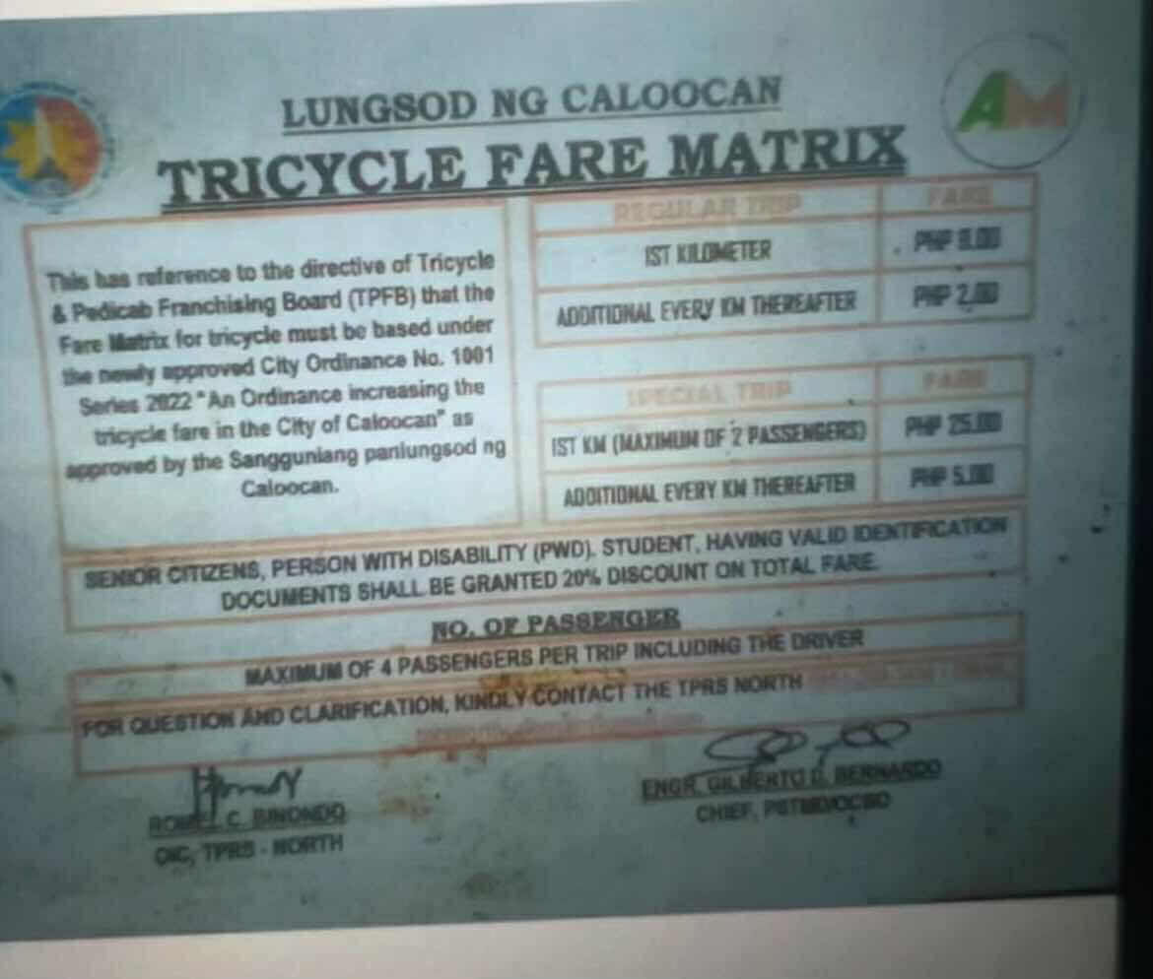

Figure 2. Tricycle Fare Matrix
A fare estimation feature is integrated into the MOTO mobile application, applying specifically to Online Bookings made through the passenger app. Onsite Bookings or Walk-ins at the TODA station, managed by barkers, will continue to follow the official TODA fare matrix approved by the local government. For Online Bookings, the system automatically estimates fares at ₱25 for the first kilometer and ₱5 for every succeeding kilometer, ensuring transparency, fairness, and consistency across all app-based ride requests. The booking service is limited to destinations within a 1.5 km radius from Barangay 177, reinforcing localized transport coverage and maintaining efficient service distribution among drivers.
Each Online Booking includes a ₱2 convenience fee as a small service charge for using the mobile platform. However, students, senior citizens, and people with disabilities (PWDs) are entitled to a 20% fare discount and are exempted from the convenience fee after submitting valid identification for admin verification through the system. This ensures that the discount privileges are applied fairly and in accordance with government fare regulations.
At present, the MOTO application supports cash-based transactions only. The ₱2 convenience fee is temporarily collected along with the fare and remitted to the tricycle association or platform administrator. In future updates, once digital payment integrations such as GCash or Maya are implemented, the convenience fee will be automatically separated from the fare to promote greater financial transparency and compliance.
The project team also recognizes that tricycle fares are regulated by the Local Government Unit (LGU) under the TODA fare matrix. Prior to full-scale deployment, coordination with the Tricycle Franchising and Regulatory Board (TFRB) will be conducted to formalize the fare computation and convenience fee under an LGU-approved digital service framework. This ensures that the pricing model aligns with existing government transport policies and community standards.
Through this initiative, MOTO promotes operational efficiency, transparency, and inclusiveness while maintaining compliance with LGU regulations. It provides passengers with accessible, fair, and reliable booking options and gives drivers structured, consistent income opportunities while supporting CCCH TODA’s shift toward sustainable, technology-driven community transportation.

3.2.1 Project Objectives
The The MOTO: Mobile Operations and Tricycle Organizer project aims to modernize and digitalize tricycle operations within Cielito Homes, Barangay 177, by resolving long-standing issues in manual contribution tracking, unorganized dispatching, and inefficient communication between passengers, drivers, and TODA operators.
Through the integration of IoT-based hardware and mobile and web applications, MOTO establishes a centralized, transparent, and technology-driven ecosystem that supports fair dispatching, efficient butaw collection, and improved passenger service.
Within the development and deployment timeline, the project will:
- Implement an RFID-based Smart Piggy Bank with LCD Display that automates driver butaw contributions and synchronizes records with the admin web dashboard and driver app. Verified drivers will log their contributions after each trip using their assigned RFID cards. The system automatically flags drivers with missed contributions, ensuring consistent accountability and financial transparency.
- Introduce an RFID Assignment System managed exclusively by the admin, utilizing an RFID scanner to link each RFID UID to a verified driver. Drivers are required to upload valid documents (e.g., driver’s license or TODA ID) during registration for admin verification and feedback before receiving their RFID card in person.
- Develop an integrated booking system that supports both Onsite (Walk-in) and Online ride requests.
  - Onsite Bookings are handled through the Barker App, allowing barkers to group up to four passengers per tricycle heading to the same destination.
  - Online Bookings are made through the passenger app, which provides real-time driver matching, fare estimation, and trip tracking.
All bookings are limited to a 1.5 km service radius from Barangay 177 to maintain localized and efficient coverage.
- Integrate IoT components such as RFID scanners, microcontrollers, and connectivity modules to link driver contributions, monitor station activity, and synchronize booking and payment data in real time.
- Develop a centralized Admin Web Dashboard that allows TODA officials to manage and monitor key operations, including driver and passenger accounts, discount verification, fare matrix configuration, queue tracking, RFID assignment, contribution monitoring, and an audit log for admin activity transparency.
- Support driver income growth and passenger satisfaction by reducing idle time, ensuring fair dispatching, and providing a reliable digital record system for rides and contributions.
- Enhance account security and accessibility by implementing phone verification during registration, role-based access, and a Forgot Password feature for both drivers and passengers.

3.2.2 Success Criteria

Table 5. Success Criteria
KPI | Target Value | Purpose
Smart Piggy Bank Transaction Accuracy | 80% or higher | Ensure correct recording of daily butaw and savings contributions
Booking Queue Efficiency | 50% reduction in waiting time | Measure effectiveness of the app booking system
System Uptime | 85% uptime in first month | Assess reliability of IoT devices and mobile integration
Financial Transparency | 85% of butaw records digitized | Promote trust and accountability within TODA
Processing Time Reduction | 50% faster compared to manual logging | Improve operational efficiency in tricycle station management
User Satisfaction Rate | 85% positive feedback or higher | Gauge satisfaction of both tricycle drivers and passengers
Admin Dashboard Utilization | 80% of TODA officials actively using | Ensure adoption and effectiveness in monitoring operations
Error Reduction | 70% decrease in manual logging/queue disputes | Minimize human errors and conflicts in operations

Quality, time, and cost benchmarks

Table 6. Quality, Time, and Cost Benchmarks
Criteria | Target | Actual Result | Status
Quality | 0 unresolved critical bugs after UAT; TODA officials approve system | Pending | Pending
Time (Schedule) | Complete within 11 weeks (design, development, testing, deployment) | Pending | Pending
Cost (Budget) | Not to exceed ₱0 (hardware, IoT integration, app development, deployment) | Pending | Pending
Stakeholder satisfaction
- Client Feedback: Project approved with enthusiasm and no major revisions.
- Instructor/Adviser Review: System meets the original objectives

3.2.3 Requirements
The project requirements outline the specific functionalities and feature to be incorporated into the MOTO: Mobile Operations and Tricycle Organizer. Each requirement has been labeled for ‘FR-01’ for Functional Requirement and ‘NFR-01’ for Non-Functional Requirement.
- Functional Requirements

Table 7. Functional Requirements
Requirement ID | Description
FR-01 | The system shall provide separate portals for passengers, drivers, barkers, and admins, accessible via mobile apps and a web dashboard, allowing users to manage bookings, contributions, profiles, and transactions according to their respective roles.
FR-02 | The RFID-based Smart Piggy Bank shall automatically record driver butaw contributions using RFID tap recognition and display confirmation on the LCD screen. All records shall synchronize in real time with the admin web dashboard and driver mobile app for transparency and accountability.
FR-03 | The system shall include an RFID Assignment Scanner feature accessible only to the admin for assigning RFID UID cards to verified drivers. RFID registration on the driver’s end is not permitted, and RFID cards are physically distributed upon approval.
FR-04 | Drivers shall be required to upload valid documents (Driver’s ID, TODA ID, etc.) during registration for admin verification. The admin must provide feedback on the driver’s registration status (Pending, Approved, or Requires Revision).
FR-05 | The system shall allow drivers to contribute their butaw after each completed trip, with the system automatically flagging accounts that fail to deposit contributions after several rides.
FR-06 | The system shall support two booking types: Onsite Booking / Walk-in, managed by barkers for passengers at the TODA station, and Online Booking, made through the passenger app within a 1.5 km radius from Barangay 177.
FR-07 | The Barker App shall allow barkers to group up to four (4) passengers per tricycle if they share similar destinations, automatically matching them with the next available driver in the queue.
FR-08 | The system shall implement fare estimation for Online Bookings starting at ₱25 for the first kilometer and ₱5 for every succeeding kilometer, with an additional ₱2 convenience fee for app-based bookings.
FR-09 | The system shall provide fare discounts of 20% for verified students, senior citizens, and PWDs, who are also exempted from the ₱2 convenience fee. Users must upload valid IDs for verification, which the admin shall confirm before activation.
FR-10 | The Admin Web Dashboard shall allow TODA officials to view and manage driver and passenger accounts, booking records, contribution logs, fare matrix configurations, queue monitoring, and discount verifications.
FR-11 | The system shall provide real-time queue tracking for drivers and automatically cancel or reassign unaccepted bookings after a defined timeout to ensure fair and organized dispatching.
FR-12 | All users (drivers, passengers, and admins) shall be able to register, log in, and manage their accounts securely, with phone number verification required during registration and a Forgot Password feature for account recovery.
FR-13 | The system shall maintain comprehensive transaction logs of all financial activities (butaw deposits, fare payments, booking fees, discounts) stored securely in the database for audit and dispute resolution.

- Non-Functional Requirements

Table 8. Non-Functional Requirements
Requirement ID | Description
NFR-01 | The system must be operational 24/7 with a minimum uptime of 90%, ensuring continuous access for daily driver contributions, bookings, and administrative monitoring. Scheduled maintenance should be announced at least 24 hours in advance.
NFR-02 | The RFID-based Smart Piggy Bank hardware must be durable, tamper-resistant, and weather-protected, capable of handling frequent RFID taps and interactions at the CCCH TODA station without malfunction or data loss.
NFR-03 | The RFID Assignment Scanner used by the admin must ensure accurate and secure UID linking between the assigned RFID card and the verified driver profile, with instant confirmation displayed on the admin dashboard.
NFR-04 | The mobile applications (Passenger, Driver, and Barker Apps) must operate smoothly on Android 10 and above, optimized for stable performance on mid-range devices with at least 4GB RAM.
NFR-05 | The Admin Web Dashboard must be accessible on modern browsers (e.g., Chrome, Edge, Firefox) and maintain responsive functionality across desktop and tablet screens.
NFR-06 | Data syncing for contributions, booking updates, and fare calculations must complete within 5–8 seconds, ensuring minimal transaction delay between the mobile app, IoT hardware, and admin dashboard.
NFR-07 | The user interface (UI) must be intuitive, responsive, and accessible, designed with simple navigation and readable elements to accommodate users with limited technical experience, including barkers and senior drivers.
NFR-08 | The system must reliably support at least 70 concurrent users (drivers, passengers, barkers, and admins) without noticeable performance degradation or system crashes.
NFR-09 | Chat sessions between drivers and passengers must automatically terminate and delete upon trip completion to protect user privacy and prevent post-transaction misuse.
NFR-10 | The system must comply with the Philippine Data Privacy Act of 2012 (RA 10173) by encrypting all sensitive information, including uploaded IDs, personal details, and financial data. Only authorized administrators can access or verify such records.
NFR-11 | The system must provide instant notifications (via pop-ups, toasts, or modals) within 3–5 seconds of trigger events, such as booking confirmation, queue updates, verification results, or flagged account alerts.
NFR-12 | The system must provide automated backup and recovery mechanisms to ensure that contribution and booking records are preserved even in the event of network failure or power interruption at the TODA station.
NFR-13 | The flagged accounts mechanism must reliably detect and mark drivers who miss post-ride contributions and inactive accounts, with notifications and dashboard alerts issued in real time for transparency and corrective action.
NFR-14 | The system must include admin action auditing, recording all sensitive operations (e.g., RFID assignment, document verification, fare matrix updates) in a secure and time-stamped audit log.

3.2.4 Constraints
This section encompasses all the limitations of budget, time, and resources boundaries that guide the execution of the project.
- The project has a maximum approved budget of ₱400,000.00, which must cover all hardware, software, and development expenses.
- The project’s components and services must be sourced within the local market or from affordable online suppliers.
- Any delay will affect the project defense and submission deadlines for the academic capstone requirements.
- Milestones such as designs, integration, testing, and documentation must follow the planned schedule strictly.
- The development team is limited to five members, each responsible for hardware, software, testing, and documentation tasks, and may require extra tasks.
- Only low-cost, widely available microcontrollers and open-source tools (e.g., ESP32, Firebase, Arduino IDE) will be used.
- Access to specialized tools or paid platforms is restricted, requiring creative solutions using available materials and knowledge.
    - Assumptions
- Drivers, barkers, and commuters will adopt the MOTO system after a short orientation and hands-on training, facilitated by the CCCH TODA officials.
- Users (drivers, passengers, and barkers) will have access to smartphones with at least Android 10.0 and active internet connectivity to operate their respective mobile apps.
- RFID-based contribution records generated by the Smart Piggy Bank will be trusted and considered valid once verified and synced to the admin web dashboard.
- The admin and authorized TODA officials are responsible for verifying uploaded driver documents, passenger discount IDs, and assigning RFID cards securely.
- Data collected from the system—including ride logs, contributions, personal information, and uploaded IDs—will be stored securely and accessible only to authorized personnel, in compliance with the Data Privacy Act of 2012 (RA 10173).
- A stable internet connection will be available to support real-time synchronization of bookings, contributions, and notifications across the IoT hardware and mobile applications.
- The TODA station will maintain the RFID Smart Piggy Bank hardware in good working condition and ensure its accessibility for daily butaw transactions.
3.2.6 Preliminary Scope Statement
In Scope:
- Development of an RFID-Based Smart Piggy Bank with LCD Display, integrated with the system for automatic contribution recording and driver verification.
- Implementation of RFID Assignment by Admin, where each driver’s RFID UID is linked to their verified profile and physically distributed at the TODA station.
- Development of mobile applications for passengers, drivers, and barkers, supporting booking, chat, fare estimation, contribution tracking, and discount verification.
- Deployment of a centralized Admin Web Dashboard for managing users, verifying IDs and documents, configuring the fare matrix, tracking contributions, and monitoring queues and bookings.
- Implementation of two booking modes:
  - Onsite Booking / Walk-in – managed through the Barker App at the TODA station for grouped or walk-in passengers.
  - Online Booking – handled through the passenger mobile app, limited to a 1.5 km service radius from Barangay 177.
- Integration of IoT components (RFID scanners, microcontrollers, connectivity modules) to support real-time data transfer between hardware and software.
- Inclusion of account security features, such as phone verification, role-based access, and Forgot Password functionality for both drivers and passengers.
Out of Scope:
- Integration with external payment platforms (e.g., GCash, Maya, or bank systems) all transactions during the initial deployment remain cash based.
- Expansion beyond Barangay 177; the pilot implementation focuses exclusively on the CCCH TODA station.
- Mass hardware production beyond prototype units; only pilot models of the Smart Piggy Bank and necessary IoT hardware will be assembled and tested.
- Maintenance or replacement of IoT hardware components after project turnover; this responsibility will be transferred to the TODA organization.
- Tricycle drivers operating outside the designated TODA station (“rumoronda”) are not covered or monitored by the MOTO system.

3.3 Risks
The MOTO: Mobile Operations and Tricycle Organizer project is inevitable to face potential risks. Here are the following potential risks that the project may encounter:

Table 9. Risk
Risk | Description | Impact | Likelihood | Mitigation Strategy
Hardware Malfunction | IoT components (smart piggy bank sensors, RFID readers and scanners, LCD displays, microcontrollers) may fail during operation | High | Medium | Conduct thorough testing before deployment; keep spare units and replacement parts on hand
Internet Downtime | Connectivity issues may disrupt mobile app syncing, booking requests, and contribution tracking | Medium | High | Implement offline caching and local queue storage; consider backup data sources (e.g., prepaid Wi-Fi or mobile data)
User Confusion | Drivers or commuters may find it difficult to use the mobile app or the piggy bank | Medium | Medium | Provide training, in-app tutorials, clear instructions, and physical signage at stations
Software Bugs | Errors in the mobile app or admin dashboard may cause failed transactions or booking errors | High | Medium | Perform extensive unit, integration, and user acceptance testing; apply regular patches and version control
Supply Delays | Smart piggy bank components may be delayed during procurement | Medium | Medium | Place hardware orders early; maintain a list of alternative suppliers
Data Privacy Breach | Unauthorized access to user savings or booking data may occur | High | Low | Implement encryption, role-based access, and comply with the Data Privacy Act (RA 10173)
Budget Overrun | Project costs may exceed the allocated ₱400,000 due to unforeseen expenses | High | Low | Strict budget tracking; prioritize core features first; defer non-essential enhancements to later phases
Low Adoption Rate | Users may hesitate to adopt the new system and stick to manual processes | Medium | Medium | Launch awareness campaigns, provide incentives (e.g., savings milestones), and conduct community demos

3.4 Project Key Deliverables
These deliverables represent the team’s essential targets required to meet the objectives.

Table 10. Project Deliverables
Deliverable | Description | Expected Date
Project Plan Document | Complete documentation including business case, scope, schedule, and budget. | August 28, 2025
MOTO System Design | Contains the design of the user interface and the included features | September 4, 2025
Piggy Bank Integration | Hardware components installed and integrated | September 25, 2025
Piggy Bank Device | Contains the application with functional unit device | October 1, 2025
System Testing & QA Feedback | Testing by barangay staff and residents for feedback | October 15, 2025
Training Materials | Documentation to guide both TODA officials and tricycle drivers on using the system. | October 18, 2025
Final Project Report & Documentation | Project report, user manuals, and training materials | October 31, 2025

3.5 Summary Milestone Schedule
The following breakdown of milestones are the team must accomplish.

Table 11. Summary Milestone Schedule
Milestone | Target Date | Remarks
Project Planning | July 30, 2025 | All teams onboard and goals, and resources aligned
Proposal Initialization | August 4, 2025 | Set goals and objectives for proposals
Proposal Finalization | August 22, 2025 | Review and refine final project
Document Finalization | August 28, 2025 | Finalized and revised the document
System Designing | August 31, 2025 | Design and draft MOTO system
System Development | September 5, 2025 | Programming the system and developing the modules
System Testing | October 2, 2025 | Evaluate the system’s performance and addressed issues/bugs
System Optimization | October 16, 2025 | Implement improvements and polish UI/UX
System Deployment | October 22, 2025 | Launch MOTO system and prepare User Manual
Project Closure | October 31, 2025 | Present the project and collect feedback

3.6 Budget Summary
This section provides the breakdown of budget summary of the project needed to support the completion of the project.

Table 12. Budget Summary
Category | Details | Estimated Cost (PHP)
Labor Costs | Project Manager (₱35,000/month x 3 months) | ₱105,000.00
Labor Costs | Software Developer (₱38,000/month x 2 months) | ₱76,000.00
Labor Costs | Hardware Engineer (₱28,000/month x 2 months) | ₱56,000.00
Labor Costs | UI/UX Designer (₱3,000/day × 20 days) | ₱60,000.00
Labor Costs | QA Tester (₱2,500/day × 30 days) | ₱75,000.00
Total Labor Cost |  | ₱372,000.00
Hardware Costs | Allan Universal Coin Slot | ₱500.00
Hardware Costs | Soldering Kit | ₱360.00
Hardware Costs | ESP32 Development Board | ₱350.00
Hardware Costs | Arduino Uno | ₱300.00
Hardware Costs | PN532 RFID Reader + Cards/Tags | ₱300.00
Hardware Costs | 16x2 LCD Display | ₱150.00
Hardware Costs | RC522 RFID Reader and Scanner | ₱130.00
Hardware Costs | LM2596 DC-DC Module | ₱95.00
Hardware Costs | Power Switch | ₱49.00
Hardware Costs | Bread Board 800 Pins | ₱60.00
Hardware Costs | MB102 Breadboard Power Supply | ₱49.00
Hardware Costs | Jumper Wires | ₱50.00
Hardware Costs | Plywood 6x14 | ₱38.00
Total Hardware Costs |  | ₱2,431.00
Software Costs | Realtime Database, Cloud Hosting, and Cloud Storage | ₱3,720.00
Software Costs | Design Tools (Figma and Canva) | ₱0.00
Software Costs | Development Tools (Android Studio and Arduino IDE) | ₱0.00
Total Software Costs |  | ₱3,720.00
Training & Documents | User manual, training materials, document printing, glossy sticker paper, and ID printing | ₱2,268.00
Operations and Maintenance | Electricity | ₱2,100.00
Contingency (10%) | 10% Contingency Cost | ₱38,251.00
Total Project Cost |  | ₱382,519

3.7 Project Approval Requirements
The project will follow a formal approval process before any execution begins. This ensures alignment, feasibility, and commitment from all key parties. The process includes:
- Submission of the full Project Charter, Cost and Benefit Analysis, and Risk Assessment documents to the advisory panel or course instructor.
- A formal review meeting involving stakeholders (e.g., client, instructor, team members).
- A detailed project plan containing of project’s milestones, activities, and timelines for implementation.
- A formal digital approval via a sign-off from stakeholders and advisers (e.g., project management tool or email confirmation).
- Criteria for approval (e.g., budget, stakeholder alignment, feasibility)
Approval Criteria

Table 13. Approval Criteria
Criteria | Description
Budget Alignment | Total projected cost is within the approved financial threshold.
Stakeholder Agreement | Key stakeholders (e.g., client, instructor) have signed off or provided positive feedback.
Feasibility | Technical and operational feasibility validated through preliminary planning.
Strategic Alignment | Project supports the client's goals for improved financial tracking and growth.
Risk Assessment | Identified key risks are manageable, with mitigation strategies outlined.
- Names/titles of approving authorities

Table 14. Names of Approving Authorities
Name | Title/Role | Responsibility
Reynaldo Pineda | CCCH Toda President | - Oversee the project and ensure the project goals align with TODA’s goal  - Support team’s decisions on project direction.

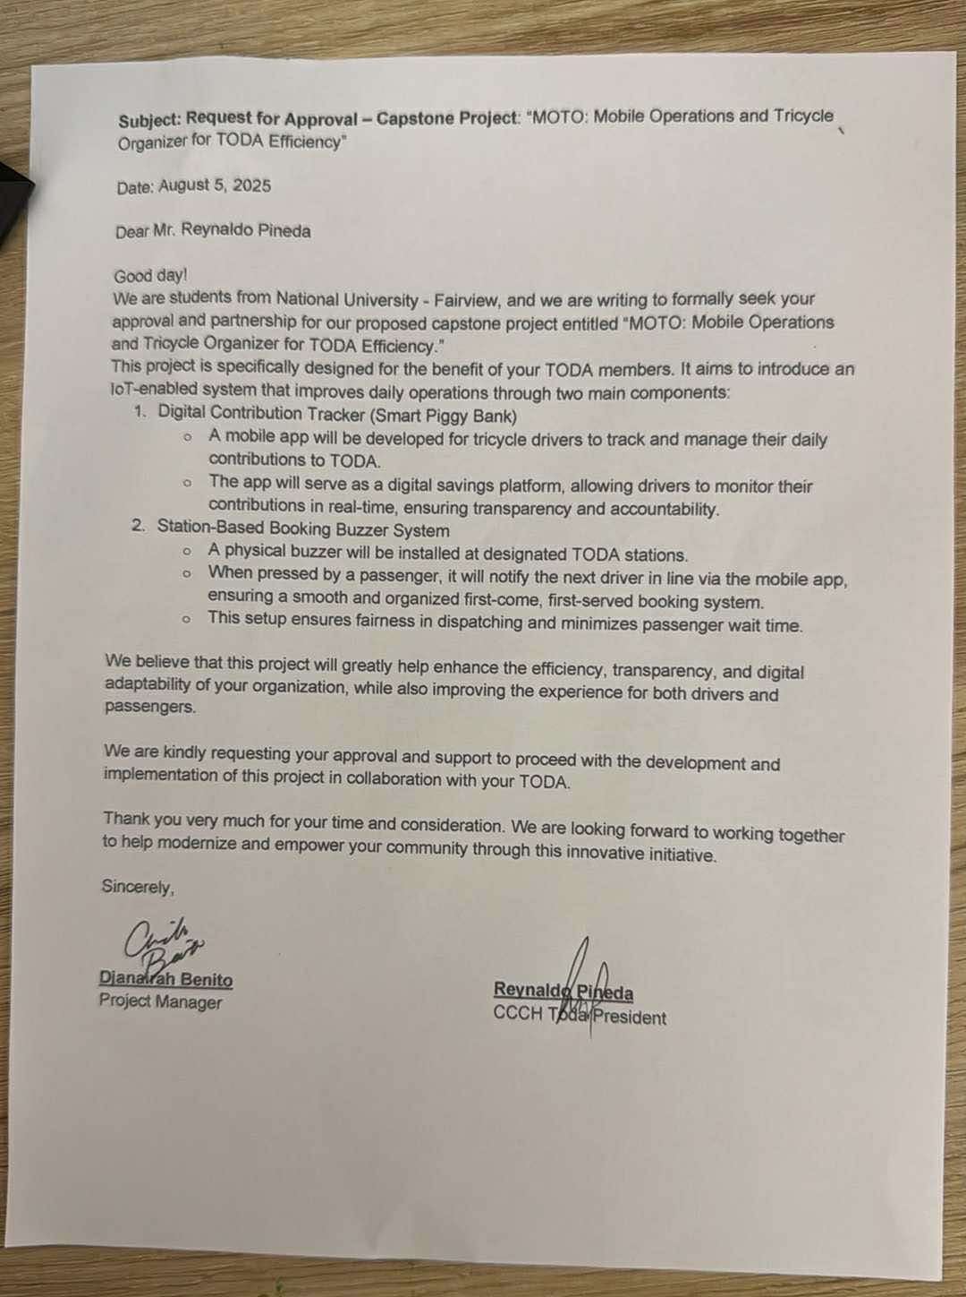 |  | 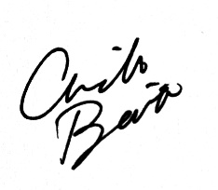  Djanairah Benito
Project Sponsor |  | Project Manager
The approval letter signed by the project sponsor from the President of Cielito Castle Spring Heights TODA after the proposed project has been explained and discussed.

Figure 2. Signed Approval Letter

4.0 Project Management Approach
The MOTO: Mobile Operations and Tricycle Organizer project will adopt the Agile project management methodology, which emphasizes iterative development, stakeholder collaboration, and continuous improvement. Agile is suitable for this project since it integrates IoT hardware (smart piggy bank with RFID and LCD) with a mobile application and dashboard, requiring flexibility to adjust to technical challenges, user feedback, and evolving requirements. Agile is particularly well-suited for this project due to its iterative nature, which allows the development team to adapt quickly to feedback from stakeholders.
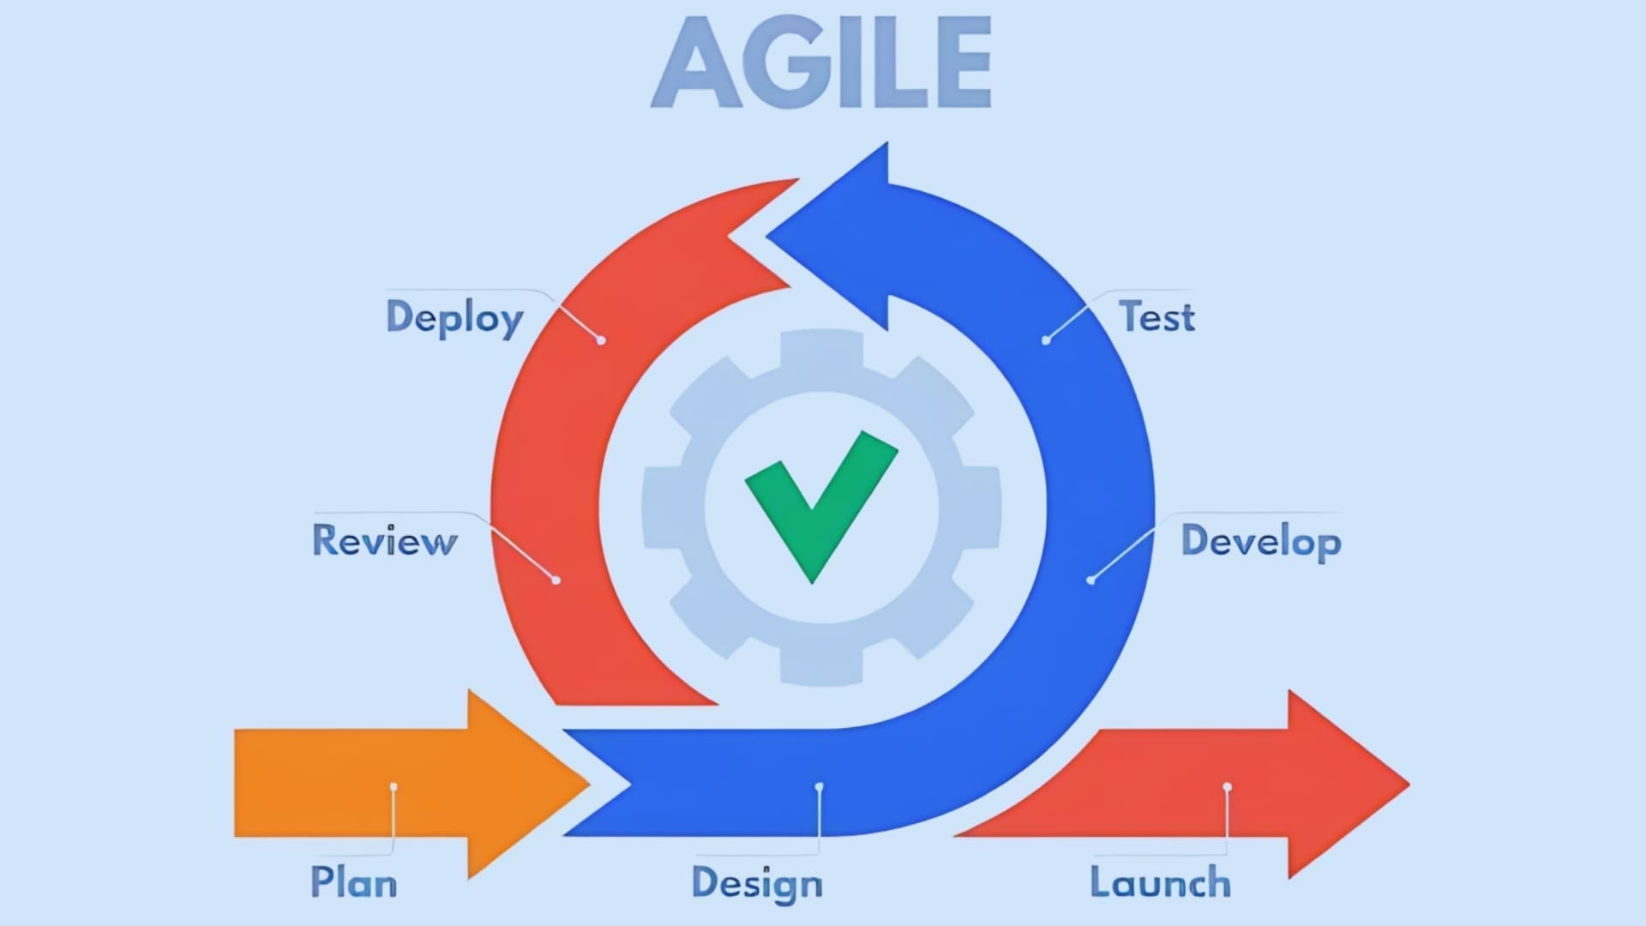

Figure 3. Agile Methodology
The project will be managed across the following key phases:
- Requirements Gathering – Collect and validate functional and non-functional requirements from TODA stakeholders (drivers, barkers, station operators, and barangay officials). Emphasize requirements related to driver document upload and verification, admin RFID assignment, post-ride contribution flows and flagged-account rules, Barker workflows, and audit logging. Use onsite interviews, quick surveys, and low-fidelity prototypes to capture real-world constraints.
- System Design – Produce architecture diagrams, data flow (including RFID UID linking), and wireframes for the Passenger, Driver, Barker apps, and Admin Web Dashboard. Design IoT schematics for the Smart Piggy Bank and RFID Assignment Scanner and define data synchronization, offline handling, and recovery behavior. Validate designs with TODA representatives to ensure usability and regulatory compliance.
- Development – Break work into 2-week sprints delivering vertical slices: authentication & account management (phone verification, Forgot Password), driver registration & document upload, admin verification & RFID assignment, Smart Piggy Bank–backend integration, booking & queueing (Onsite/Online), Barker app workflows (grouping up to 4 pax), fare estimation & fare matrix, and admin audit & reporting. Each sprint ends with a demo for stakeholders and a prioritized backlog grooming session.
- Testing – After development, the system will undergo rigorous testing, including unit testing of hardware modules and integration testing for mobile–IoT synchronization. For the User Acceptance Testing (UAT) phase, the ByteSize team members will temporarily serve as test users due to the recent typhoons that have made it difficult to conduct field testing with tricycle drivers. The team will simulate driver and passenger interactions to ensure reliability, functionality, and usability. Once conditions improve, actual tricycle drivers and operators will be engaged for final validation to ensure the solution performs effectively in real-world conditions.
- Deployment – Deploy the system initially in a controlled pilot at the CCCH TODA station to validate real-world performance—covering RFID issuance by admin, driver onboarding, contributions after-ride flows, Barker-managed walk-ins, and admin dashboard operations. Gather operational metrics, driver/passenger feedback, and log audit activity for refinement.
- Full Deployment & Training: Following successful pilot refinements, perform full installation of Smart Piggy Bank hardware and the admin RFID assignment scanner, roll out mobile apps to users, and conduct hands-on training sessions for drivers, barkers, and TODA officials. Provide user manuals, quick-reference guides, and in-app help to ease adoption.
- Maintenance and Support – After turnover, the team will provide short-term post-deployment support and a knowledge transfer package (maintenance procedures, spare parts list, and admin guide). Long-term hardware maintenance responsibility will be transferred to CCCH TODA per the project’s Out-of-Scope agreement. The development team will provide a documented escalation and bug-fix plan for a defined warranty/support period.
This Agile, stakeholder-driven approach ensures each technical and process update (RFID assignment, document verification, Barker workflows, flagged accounts, audit logging, and admin dashboard control) is developed, tested, and validated in collaboration with CCCH TODA—reducing deployment risk and increasing the chance of broad adoption and long-term sustainability.
Tools and Software
The following tools will support efficient tracking, collaboration, and progress monitoring:

Table 15. Tools and Software
Tool | Purpose
MS Teams | For task management and sprint tracking
Google Drive / GitHub | For documentation sharing and storage
Figma / Canva | For UI/UX design mockups and creating visual assets or presentations
Messenger / Email | For daily/weekly communication with the client and team
Android Studio | For programming Mobile-Based application
Arduino IDE | For programming and uploading code to the Arduino microcontroller

Roles and Responsibilities

Table 16. Roles and Responsibilities
Name | Role | Responsibilities
Benito, Djanairah | Project Manager | Oversee schedule, defines task timelines, monitors progress, and ensures timely delivery of all components. Monitors milestone progress, ensures scheduling aligns with TODA goals and academic timelines
Choa, Jerycho Roniel | Software Developer | Develops and maintains the mobile application, admin dashboard, and backend services. Implemented features such as booking management, fare estimation for special bookings, and contribution tracking.
Zamodio, Ken Aixroch | Hardware Engineer | Manages hardware development, including the RFID-enabled smart piggy bank with LCD and the booking system for drivers at the CCCH TODA station. Ensures proper integration with the mobile app and backend.
Capawing, Eulan Miguel | UI/UX Designer and QA / Tester | Aligns interface development with sprint cycles; ensures UI assets are delivered on time. Schedules and conducts testing cycles; reports bug and verifies fixes during key phases
Communication Plan
- Weekly Check-ins (via Messenger/Google Meet) to review progress and discuss blockers
- Bi-weekly Reports summarizing accomplishments, issues, and next steps
- Client Feedback Sessions during Testing and Monitoring phases
- Final Presentation at the end of Week 10 for system handover and documentation
Risk and Change Management
- A Risk Register will be created and maintained throughout the project to track potential risks.
- Risks will be prioritized based on their impact and likelihood.
- Contingency plans will be outlined for high and medium-level risks to ensure project resilience.
- Any changes to scope, budget, or timeline must:
- Be formally discussed with the Project Manager.
- Receive approval from the client (CCCH TODA President) or supervising instructor before implementation.
Quality Assurance Practices
- Code and feature reviews after each sprint
- Usability testing with TODA officials and volunteered passengers
- Final acceptance testing and feedback in Week 9

5.0 Project Technical Approach
The MOTO: Mobile Operations and Tricycle Organizer system will be developed using a combination of IoT hardware, mobile applications, and a secure back-end infrastructure, creating an integrated and efficient platform tailored to the needs of tricycle drivers, barkers, passengers, and TODA administrators.
This system aims to digitize butaw (daily contribution) tracking, organize passenger booking and queueing, and improve accountability in TODA operations, replacing traditional manual methods with an automated, data-driven approach.
The technical architecture is composed of three major layers:
- IoT Hardware Layer (RFID devices and sensors)
- Mobile and Web Application Layer (user interfaces)
- Back-End Layer (server and database infrastructure)
Hardware Components
- RFID-Based Smart Piggy Bank with LCD Display Installed at the CCCH TODA station, this device records butaw contributions when verified drivers tap their assigned RFID cards. Once a contribution is logged, it appears instantly on the LCD screen and syncs with the system’s database and admin dashboard. Drivers are allowed to contribute after each ride, and the system automatically flags accounts that miss contributions, promoting accountability.
- RFID Assignment Scanner (Admin Only) Used exclusively by the admin to assign RFID cards to verified drivers. After drivers register and upload their required documents, the admin reviews their submissions and assigns RFID UID cards via this scanner. Drivers then claim their physical RFID cards in person at the TODA station.
The IoT devices will connect to the back-end system through Wi-Fi or GSM (mobile data) on site infrastructure, enabling synchronization of logs, contributions, and booking data.
Software and Mobile Application
The MOTO ecosystem consists of three mobile applications (Passenger App, Driver App, and Barker App) and an Admin Web Dashboard.
Passenger App
- Allows users to book tricycle rides through Online Booking (within a 1.5 km radius from Barangay 177).
- Supports fare estimation starting at ₱25 for the first kilometer and ₱5 for each succeeding kilometer, with an added ₱2 convenience fee for app-based bookings.
- Offers discount eligibility for students, senior citizens, and PWDs, who can upload valid IDs for admin verification to receive a 20% fare discount and fee exemption.
- Includes a real-time chat system for active rides and live trip tracking for improved safety and coordination.
Driver App
- Displays contribution history, post-ride contribution option, and account status (notices for missed butaw).
- Includes a Contributions Tab and an RFID Tab where drivers can report lost cards.
- Supports queue monitoring, ride notifications, and in-app chat for passenger coordination.
- Integrates driver verification, where drivers upload necessary documents for admin approval. Drivers also receive feedback regarding their registration status (Pending, Approved, or Requires Revision).
Barker App
- Designed for Onsite Bookings / Walk-in passengers.
- Allows barkers to group up to four (4) passengers per tricycle when destinations are similar.
- Automatically assigns the next available driver in the queue, optimizing dispatching and fairness.
Admin Web Dashboard
- Provides centralized control and monitoring for TODA officials and operators.
- Key features include:
  - RFID Assignment and UID linking for verified drivers
  - Driver and Passenger Account Management
  - Verification of Uploaded IDs and Documents
  - Contribution and Queue Monitoring
  - Fare Matrix Configuration and Adjustment
  - Discount Verification and Approval
  - Audit Log Tracking for all admin activities
- Accessible via desktop or tablet browsers, offering a secure and role-based interface for managing TODA operations.
Back-End System and Database
The back end will be powered by Firebase Realtime Database, offering secure and scalable cloud-based storage for all operational data. It manages:
- User authentication (with phone verification and Forgot Password support)
- Real-time synchronization of bookings, contributions, and chat messages
- Storage and encryption of sensitive data (driver documents, passenger IDs, and RFID UIDs)
- Role-based access control for drivers, passengers, barkers, and admins
- Audit logs for transparency and traceability of administrative actions
This technical approach ensures that every hardware and software component is directly mission-aligned, digitizing butaw collection, enforcing fairness in passenger dispatching, and providing TODA leaders with automated records for accountability. With its scalable and IoT-driven design, MOTO positions Cielito Homes TODA as a modernized, transparent, and community-focused transport service.

5.1 Product Development Methodology
The MOTO project will adopt the Agile methodology, specifically following Scrum practices, to manage both hardware and software development phases. This approach provides flexibility, encourages continuous feedback, and supports incremental delivery key for an IoT system involving multiple components like the RFID-enabled smart piggy bank, a booking system, mobile app, and admin dashboard.
The project will be divided into sprints, each lasting approximately two weeks. At the beginning of each sprint, the team will conduct sprint planning to prioritize features based on stakeholder input and technical feasibility. Key deliverables such as modules for contribution tracking, booking management, queue display, fare estimation for special bookings, and admin dashboard monitoring will be broken down into manageable tasks and tackled incrementally.
- Development will proceed in structured 2-week sprints with the following routine:
  - Daily stand-ups for quick progress updates
  - Sprint planning meetings to set goals and allocate tasks
  - Collaborative coding and integration between hardware and software teams
  - Mid-sprint demos and QA testing for usability and stability
  - Sprint reviews and retrospectives to reflect on progress and adapt plans
Each sprint will deliver a key module such as the RFID piggy bank system, a booking system control, mobile booking and queue tracking features, or the notification and chat engine, allowing for continuous validation and iteration based on stakeholder and TODA feedback.

5.2 Technical Architecture
The MOTO: Mobile Operations and Tricycle Organizer adopt a mobile-first and IoT-integrated architecture designed to deliver accessibility, transparency, and real-time monitoring for drivers, barkers, passengers, and TODA officials. Its architecture ensures seamless communication between hardware devices, mobile applications, and the admin web platform, enabling automated contribution tracking, organized queue management, and data-driven decision-making for CCCH TODA operations.
At the core of MOTO is a multi-role mobile system developed primarily using Android Studio, supported by an Admin Web Dashboard and a Firebase Cloud Back-End. Each system component serves a specific function:
- Drivers use the mobile app to log butaw contributions via RFID, view contribution history, check queue position, receive ride notifications, and monitor alerts for missed post-ride deposits and inactive accounts
- Passengers use the app to book Online Rides within a 1.5 km radius of Barangay 177, receive fare estimates, upload discount IDs (Student, Senior, PWD) for verification, and communicate with drivers via in-app chat during active bookings.
- Barkers use their dedicated app to manage Onsite/Walk-in bookings, grouping up to four passengers per tricycle and automatically matching them with the next available driver in the queue.
- Admins/TODA Officials use the Web Dashboard to monitor contributions, manage RFID assignments, verify uploaded IDs and driver documents, configure fare matrices, track queues, and oversee all system logs and audit records.
The mobile and web applications communicate securely with the back end through encrypted API endpoints, ensuring reliable synchronization of all booking, payment, and contribution data. All records are stored in a centralized Firebase Realtime Database, ensuring real-time data updates and redundancy across connected devices.
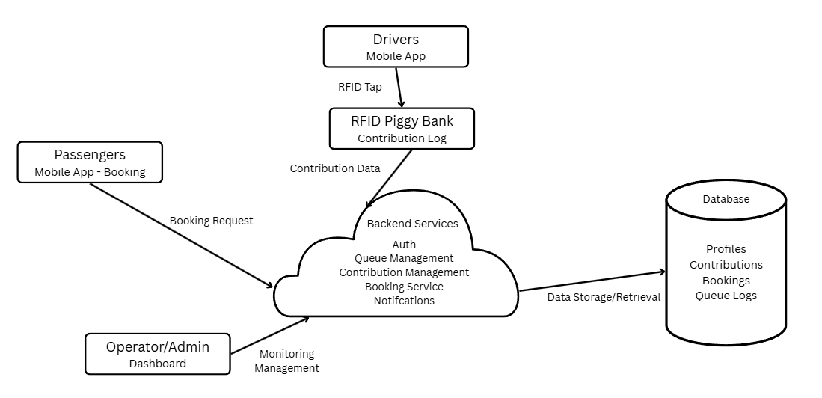

Figure 4. MOTO System Architecture Diagram
Hardware Components
- RFID-Based Smart Piggy Bank with LCD Display: Installed at the CCCH TODA station, this device records driver contributions through RFID authentication and displays confirmation messages on the LCD screen. Once validated, the contribution data is automatically synced to the Firebase database and reflected in the admin dashboard. Drivers can now contribute after each ride, providing flexibility while maintaining accountability through the system’s flagged account mechanism for unrecorded contributions and inactive accounts.
- RFID Assignment Scanner (Admin-Only): This device is used exclusively by TODA admins to assign RFID cards to verified drivers. After drivers upload their documents during registration, the admin verifies their credentials, provides registration feedback (Pending, Approved, or Requires Revision), and assigns an RFID UID to link the driver’s account with their RFID card. RFID cards are then distributed in person to ensure authenticity and controlled issuance.
- Connectivity (Wi-Fi / GSM): The IoT devices connect to the system via Wi-Fi or mobile data networks, allowing real-time synchronization of butaw records, queue data, and RFID transactions even in areas with limited infrastructure.
Software Architecture
The MOTO ecosystem consists of the following integrated software modules:
- Passenger App (Android): Handles Online Booking, fare estimation, trip tracking, and discount verification.
- Driver App (Android): Manages ride notifications, post-ride contributions, RFID reporting, and compliance status.
- Barker App (Android): Manages Onsite Bookings / Walk-ins, enabling passenger grouping and automated driver matching.
- Admin Web Dashboard: Provides comprehensive oversight, including contribution and queue tracking, fare matrix setup, RFID assignment, and an audit log to track all administrative actions.
Back-End and Database Layer
The system’s back-end leverages Firebase Realtime Database and Firebase Authentication, providing:
- Real-time synchronization between mobile apps, IoT devices, and the web dashboard.
- Secure data storage and encryption for user profiles, contributions, and booking transactions.
- Role-based access control for drivers, passengers, barkers, and admins.
- Forgot Password and phone number verification for secure authentication.
- Audit logs for tracking admin activities, document approvals, fare updates, and RFID assignments.
Security and Notifications
- Data Security: For the in-app chat feature messages are encrypted and transmitted securely but not stored in the database, ensuring privacy while preventing unnecessary data retention.
- Push Notifications: keeping drivers updated on deposits/earnings and commuters informed on queue or booking status.
- OpenRoute Service API Integration: Used for map services and route calculations, particularly for special app-based bookings. It validates the 1.5 km radius restriction from Barangay 177 and computes estimated fares for these trips, ensuring accuracy and transparency.
This architecture directly supports the project’s objective of digitizing contribution management, ensuring fair booking, and enhancing accountability in TODA operations. By focusing on a mobile-first system integrated with IoT hardware and mapping services, MOTO provides a secure, scalable, and user-friendly platform that modernizes tricycle operations while remaining adaptable to future upgrades.

6.0 Project Management Plan

6.1 Stakeholders Strategy Management Plan
This section outlines the strategy for identifying, engaging, and managing key stakeholders throughout the development and implementation of the MOTO: Mobile Operation and Tricycle Organizer project.
Stakeholder Identification:
The Stakeholders in the project will play critical role in both implementation and usage of MOTO: Mobile Operation and Tricycle Organizer system. The following stakeholders are identified as:

Table 17. Stakeholder Identification
Name | Role | Influence Level | Interest Level
Reynaldo Pineda | Project Sponsor | Medium | High
Warren Panizales | Project Adviser | High | High
Renan Bacit | Project Consultant | High | High
Djanairah Benito | Project Manager | Medium | High
Eulan Miguel Capawing | UI/UX Designer and QA / Tester | Medium | High
Jerycho Roniel Choa | Hardware Engineer | Medium | High
Ken Aixroch Zamodio | Software Developer | Medium | High
Passengers | End Users | High | High
Stakeholder Analysis:

Table 18. Stakeholder Analysis
Stakeholder | Power | Interest | Quadrant
Reynaldo Pineda | High | High | Keep Informed
Warren Panizales | Medium | High | Keep Informed
Renan Bacit | Medium | High | Keep Informed
Djanairah Benito | Medium | High | Managing
Eulan Miguel Capawing | Medium | High | Managing
Jerycho Roniel Choa | Medium | High | Managing
Ken Aixroch Zamodio | Medium | High | Managing
Passengers | Low | High | Monitor

Engagement Plan:

Table 19. Engagement Plan
Stakeholder | Engagement Strategy | Communication Channel | Frequency
Reynaldo Pineda | Keep informed and involved in updates | Face-to-face, Email Messenger | Per milestone
Warren Panizales | Consulting the system and proposing solution | Face-to-face, Messenger, MS Teams | Weekly
Renan Bacit | Consulting the system and proposing solution | Face-to-face, Messenger, MS Teams | Weekly
Djanairah Benito | Creating and analyzing the Project System | Face-to-face, Messenger, MS Teams | Daily
Eulan Miguel Capawing | Creating and analyzing the Project System | Face-to-face, Messenger, MS Teams | Daily
Jerycho Roniel Choa | Creating and analyzing the Project System | Face-to-face, Messenger, MS Teams | Daily
Ken Aixroch Zamodio | Creating and analyzing the Project System | Face-to-face, Messenger, MS Teams | Daily
Passengers | Educate and inform on piggy bank services and access methods | Bulletin Board, social media | During rollout
Escalation Process:
If stakeholder concerns cannot be resolved within the team, they shall be escalated to the Project Adviser and Consultant within 24 hours and to Project Sponsor within one (1) to two (2) business days if unresolved.

6.2 Scope Management Plan
The Scope Management Plan defines how the scope of the MOTO: Mobile Operation and Tricycle Organizer project will be identified, validated, and controlled to ensure that all deliverables meet the project’s objectives. The plan establishes clear guidelines for what is included in the project and what falls outside its scope, ensuring alignment with the core goal of addressing the challenges of butaw contribution tracking and improving TODA income through a mobile-enabled booking and queueing system.
Scope Statement
Inclusions
The MOTO System encompasses the development of IoT-integrated hardware, mobile applications (Passenger, Driver, and Barker apps), and an Admin Web Dashboard designed to support efficient and transparent TODA operations.
Mobile Application Development:
Driver App:
- Allow verified drivers to log on trips, track income, and monitor post-ride butaw contributions.
- Provides real-time notifications for bookings, queue position, and alerts for missed contributions.
- Includes tabs for Contributions and RFID Management, allowing drivers to report lost RFID cards and review contribution history.
- Supports document upload during registration, with admin feedback on status (Pending, Approved, or Requires Revision).
Passenger App:
- Enables passengers to make Online Bookings (limited to a 1.5 km radius from Barangay 177).
- Displays booking status, fare estimates, and trip tracking in real time.
- Allow users to chat with drivers during active rides for coordination.
- Supports discount verification for students, senior citizens, and PWDs through ID upload; verified users receive a 20% discount and are exempt from the ₱2 convenience fee.
Barker App:
- Designed for managing Onsite Bookings / Walk-ins at the TODA station.
- Allows barkers to group up to four (4) passengers per tricycle when heading to similar destinations.
- Automatically assigns the next available driver in the queue, ensuring fair and organized dispatching.
IoT Hardware Integration:
- RFID-Enabled Smart Piggy Bank with LCD Display: Installed at the CCCH TODA station, this device records driver contributions after each ride using RFID authentication and displays confirmation on the LCD screen. Data automatically syncs with the database and admin dashboard.
- RFID Assignment Scanner (Admin-Only): Used to assign RFID UID cards to verified drivers. After registration and document approval, admins link the driver’s account to their RFID card. RFID distribution is done in person to ensure authenticity and controlled issuance.
Admin Web Dashboard and Back-End Management
- Provides a centralized web-based control panel for TODA officials to manage:
  - Driver and Passenger Accounts
  - Document and ID Verification
  - RFID Assignments and Monitoring
  - Queue and Contribution Tracking
  - Fare Matrix Configuration and Adjustment
  - Discount Applications and Approvals
  - Audit Log of all administrative activities for transparency.
- Enables real-time data synchronization with mobile apps and IoT devices via Firebase Realtime Database for continuous monitoring of transactions, bookings, and compliance.
Exclusions
The following are outside the scope of this project:
- Integration with third-party financial systems (e.g., GCash, Maya, or bank accounts); all transactions during the pilot are cash-based.
- Deployment outside Barangay 177; the initial rollout is localized at the CCCH TODA station.
- Mass production of IoT devices; only prototype units of the Smart Piggy Bank and RFID Assignment Scanner will be fabricated for pilot testing.
- Post-deployment maintenance and 24/7 technical support after turnover; ongoing maintenance will be handled by the TODA organization.
- Tricycle drivers operating outside the TODA station ("rumoronda") are not covered or monitored by the MOTO system.
- Implementation of web-based passenger or driver portals; the system focuses on mobile-first applications integrated with the admin web dashboard.
Scope Validation Process
A series of approval from the Project Sponsor, Project Adviser, Project Consultant, and Project Manager is required in case of changes in the project scope.
The following needed for the scope validation process for the project:
- Stakeholders’ approval project deliverables
- Acceptance Criteria
- Project Plan and other documents needed.
Scope Control Procedures
- Any requested changes to the project scope must be formally submitted using a Change Request Form.
- The form will outline the proposed change, justification, and its impact on the project timeline, resources, and costs.
- Change requests may be submitted by any project stakeholder, including, developers, or consultants.

6.3 Cost Management Plan
This plan explains how the MOTO system project costs will be estimated, budgeted, managed, and controlled throughout its lifecycle.
1. Cost Estimating Methodology:
Using the Bottom-up Estimating to itemize each individual component such as hardware, software, labor, miscellaneous, and contingency and give a specific cost estimate. Prices each component may vary with the choice of component’s sources and cost values were aggregated to arrive at the total project estimate.
Category | Details | Monthly/Day Cost | Duration | Estimated Cost (PHP)
Labor Costs | Project Manager | ₱38,000.00 | 3 months | ₱105,000.00
Labor Costs | Software Developer | ₱35,000.00 | 2 months | ₱76,000.00
Labor Costs | Hardware Engineer | ₱28,000.00 | 2 months | ₱56,000.00
Labor Costs | UI/UX Designer | ₱3,000.00 | 20 days | ₱60,000.00
Labor Costs | QA Tester | ₱2,500.00 | 30 days | ₱75,000.00
Total Labor Costs |  |  |  | ₱372,000.00

Table 20. Bottom-Up Estimation for Labor

Table 21. Bottom-Up Estimation for Hardware
Category | Details | Pieces/Set | Cost Per Piece/Set
Hardware Costs | Allan Universal Coin Slot | 1 set | ₱500.00
Hardware Costs | Soldering Kit | 1 set | ₱360.00
Hardware Costs | ESP32 Development Board | 1 pc | ₱350.00
Hardware Costs | Arduino Uno | 1 pc | ₱300.00
Hardware Costs | PN532 RFID Reader + Cards/Tags | 1 pc | ₱300.00
Hardware Costs | 16x2 LCD Display | 1 pc | ₱150.00
Hardware Costs | RC522 RFID Reader and Scanner | 1 pc | ₱130.00
Hardware Costs | LM2596 DC-DC Module | 1 pc | ₱95.00
Hardware Costs | Power Switch | 1 pc | ₱49.00
Hardware Costs | Bread Board 800 Pins | 1 pc | ₱60.00
Hardware Costs | MB102 Breadboard Power Supply | 1 pc | ₱49.00
Hardware Costs | Jumper Wires | 40 pcs | ₱50.00
Hardware Costs | Plywood 6x14 | 1 set | ₱38.00
Total Hardware Costs |  |  | ₱2,431.00

Category | Details | Cost | Duration | Estimated Cost (PHP)
Software Costs | Realtime Database, Cloud Hosting, and Cloud Storage | ₱310/month | 1 year | ₱3,720.00
Software Costs | Design Tools | ₱0.00 | Free Tier | ₱0.00
Software Costs | Development Tools | ₱0.00 | Free Tier | ₱0.00
Total Software Costs |  |  |  | ₱3,720.00

Table 22. Bottom-Up Estimation for Software

Category | Details | Pieces/Set | Estimated Cost (PHP)
Training & Documents | User Manuals | 70 pcs | ₱700.00
Training & Documents | Training Materials | 5 pcs | ₱900.00
Training & Documents | Document Printing | 1 set | ₱500.00
Training & Documents | Glossy Sticker Paper | 1 set | ₱78.00
Training & Documents | ID Printing (for 3 pcs of RFID Cards) | 3 pcs | ₱90.00
Total Training and Documents Costs |  |  | ₱2,268.00

Table 23. Bottom-Up Estimation for Training and Documents

Category | Details | Estimated Cost (PHP)
Operating & Maintenance | Electricity | ₱2,100.00
Total Training and Documents Costs |  | ₱2,100.00

Table 24. Bottom-Up Estimation for Operation and Maintenance

Table 25. Bottom-Up Estimation for Miscellaneous and Contingency
Category | Details | Estimated Cost (₱)
Contingency (10%) | (Subtotal of all categories) x 10%  (₱372,000 + ₱2,431 + ₱3,720 + ₱2,268 + ₱2,100 x 10%) | ₱38,251.00
The total project cost will be approximately ₱382,519.
2. Budgeting:
The total estimated project budget is ₱382,519. This budget supports all key project phases including labor, hardware procurement, software tools, testing and deployment activities, training, and documentation. A 10% contingency reserve, amounting to ₱38,251.00, is allocated to account for any unforeseen costs, such as hardware replacements, extended testing requirements, or emergency implementation support.
3. Cost Control Process:
Cost control will be conducted using a milestone-based cost tracking system rather than Earned Value Management (EVM), which is deemed more practical for this project scale. The Project Manager is responsible for:
- Tracking and comparing actual expenditures against the budget.
- Reviewing milestones to ensure budget adherence.
- Approving or escalating any additional expenditure.
- Generating monthly cost reports for school administration.
- Conducting internal bi-weekly cost reviews for continuous oversight.
Proactive cost control will ensure the project remains financially on track and responsive to any budgetary risks.

6.4 Schedule Management Plan
The Schedule Management Plan outlines how the project schedule will be created, monitored, controlled, and modified throughout the development of the MOTO system. It ensures timely task execution, milestone tracking, and alignment with the academic and community timelines.
WBS (Work Breakdown Structure):
The Work Breakdown Structure outlines the major phases, deliverables, and tasks involved in the development of the MOTO: Mobile Operations and Tricycle Organizer system. This segment provides a comprehensive understanding of the project’s task and requirements. This will help the project team to execute and monitor the project activities.

Table 26. Work Breakdown Structure
WBS ID | Description | Duration | Start Date | Resource Names
1 | Project Planning | 5 days | July 30, 2025 | Benito, Djanairah
1.1 | Stakeholder Management | 2 days | July 31, 2025 | Brillantes, Nathaniel
1.2 | Scope Management | 3 days | August 3, 2025 | Capawing, Eulan Miguel
2 | Project Initialization | 12 days | August 4, 2025 | Benito, Djanairah
2.1 | Cost Management | 3 days | August 7, 2025 | Zamodio, Ken Aixroch
2.2 | Schedule Management | 3 days | August 10, 2025 | Benito, Djanairah
2.3 | Staffing Management | 3 days | August 10, 2025 | Capawing, Eulan Miguel
2.4 | Communication Management | 3 days | August 10, 2025 | Brillantes, Nathaniel
2.5 | Change Management | 3 days | August 14, 2025 | Choa, Jerycho Roniel
2.6 | Quality Management | 3 days | August 18, 2025 | Zamodio, Ken Aixroch
3 | Project Finalization | 6 days | August 22, 2025 | Benito, Djanairah
3.1 | Risk Management | 2 days | August 22, 2025 | Brillantes, Nathaniel
3.2 | Procurement Management | 1 day | August 25, 2025 | Capawing, Eulan Miguel
3.3 | Project Final Documentation | 3 days | August 27, 2025 | Benito, Djanairah
4 | Project Documentation | 2 days | August 28, 2025 | Benito, Djanairah
5 | System Design | 4 days | August 31, 2025 | Benito, Djanairah
5.1 | UI/UX and Circuit Layout Design | 4 days | September 1, 2025 | Capawing, Eulan Miguel
 |  |  |  | Zamodio, Ken Aixroch
6 | System Development | 26 days | September 5, 2025 | Choa, Jerycho Roniel
6.1 | Software Development | 19 days | September 5, 2025 | Choa, Jerycho Roniel
6.2 | Hardware Development | 19 days | September 5, 2025 | Zamodio, Ken Aixroch
6.3 | Component Prototype | 7 days | September 25, 2025 | Choa, Jerycho Roniel
 |  |  |  | Zamodio, Ken Aixroch
7 | System Testing | 13 days | October 2, 2025 | Brillantes, Nathaniel
7.1 | Testing of the System | 5 days | October 2, 2025 | Brillantes, Nathaniel
7.2 | Data Gathering Analysis | 3 days | October 8, 2025 | Brillantes, Nathaniel
7.3 | Calibrating Modules | 5 days | October 12, 2025 | Zamodio, Ken Aixroch
8 | System Optimization | 5 days | October 16, 2025 | Brillantes, Nathaniel
8.1 | Feedback Implementation | 2 days | October 16, 2025 | Zamodio, Ken Aixroch
 |  |  |  | Choa, Jerycho Roniel
8.2 | Quality Assurance | 2 days | October 19, 2025 | Brillantes, Nathaniel
8.3 | Stakeholder Training | 1 day | October 21, 2025 | Capawing, Eulan Miguel
9 | System Deployment | days | October 22, 2025 | Choa, Jerycho Roniel
9.1 | Piggy Bank Installation | 2 days | October 22, 2025 | Zamodio, Ken Aixroch
9.2 | MOTO System | 1 day | October 25, 2025 | Choa, Jerycho Roniel
9.3 | Staff Training | 1 day | October 27, 2025 | Benito, Djanairah
10 | Project Closure | 1 day | October 29, 2025 | Benito, Djanairah
10.1 | Final-Launch Support | 1 day | October 29, 2025 | Benito, Djanairah
Scheduling Tool:
The primary tool will be used for scheduling in this project is Microsoft Team (MS Teams). This platform allows the team to have a cooperative environment workspace to chat and video conference, assign responsibilities, manage task progress and reminders, and track dependencies.
Activity Definition:
The project follows a structured scheduling method using the Work Breakdown Structure (WBS) as the foundation. Task durations are estimated via expert judgment, and historical data. The Three-Point estimation technique will be utilized where the accuracy is needed, considering the optimistic, most likely, and pessimistic activities. The formula used for calculating the weighted average = (O+4M+P)/6 then ÷ 8 to convert hours → days.

Table 27. Three-Point Estimation
Task | Optimistic (days) | Most Likely (days) | Pessimistic (days) | Weighted Average (days)
Project Concept & Initialization | 3.00 | 1.88 | 6.00 | 2.75
Research | 3.00 | 2.50 | 6.50 | 3.25
Project Charter | 9.00 | 7.00 | 10.50 | 7.92
Stakeholder Management | 6.00 | 3.00 | 7.00 | 4.17
Scope Management | 9.00 | 7.00 | 10.50 | 7.92
Cost Management | 9.00 | 7.00 | 10.50 | 7.92
Schedule Management | 3.00 | 1.50 | 4.50 | 2.25
Staffing Management | 3.00 | 1.25 | 4.50 | 2.08
Communication Management | 3.00 | 1.00 | 4.50 | 1.92
Change Management | 9.00 | 7.00 | 10.50 | 7.92
Quality Management | 12.00 | 5.25 | 13.00 | 7.67
Risk Management | 6.00 | 3.00 | 7.00 | 4.17
Procurement Management | 3.00 | 1.50 | 4.50 | 2.25
Project Closeout | 9.00 | 7.00 | 10.50 | 7.92
Task Dependencies:
This section shows the sequence in which tasks are related to one another and specify how a task starts and finishes. This allows the team to define how one task is related to another and ensure that the project flows logically and efficiently by using types like Finish-to-Start (FS), Start-to-Start (SS), Finish-to-Finish (FF), and Start-to-Finish (SF), which accurately express these linkages.

Table 28. Task Dependencies
Task ID | Task Name | Dependent | Type | Remarks
T1 | Project Concept & Initialization | - | - | Identifies the scope, goals, and objectives.
T2 | Research | T1 (Project Concept & Initialization) | Finish-to-Start (FS) | Can start only after Project Concept and Initialization is finished.
T3 | Project Charter | T2 (Research) | Finish-to-Start (FS) | Begins after the Research complete.
T4 | Stakeholder Management | T3 (Project Charter) | Finish-to-Start (FS) | Starts once Project Charter is done
T5 | Scope Management | T4 (Stakeholder Management) | Finish-to-Start (FS) | Depends on completion of Stakeholder Management
T6 | Cost Management | T5 (Scope Management) | Finish-to-Start (FS) | Begins after Scope Management finishes
T7 | Schedule Management | T6 (Cost Management) | Finish-to-Start (FS) | Starts after Cost Management is complete
T8 | Staffing Management | T7 (Schedule Management) | Finish-to-Start (FS) | Can only start after Schedule Management ends
T9 | Communication Management | T8 (Staffing Management) | Finish-to-Start (FS) | Dependent on completion of Staffing Management
T10 | Change Management | T9 (Communication Management) | Finish-to-Start (FS) | Begins after Communication Management is finished for the feedback.
T11 | Quality Management | T10 (Change Management) | Finish-to-Start (FS) | Quality Management starts only after Change Management is done
T12 | Risk Management | T11 (Quality Management) | Finish-to-Start (FS) | Requires completed Quality Management
T13 | Procurement Management | T12 (Risk Management) | Finish-to-Start (FS) | Procurement Management begins after Quality Management
T14 | Project Closeout | T13 (Procurement Management) | Finish-to-Start (FS) | Final task based on Procurement Management

Schedule Control Process
Weekly progress check-ins will be carried out and compared to the baseline schedule to make sure the project stays on course. Early detection of any discrepancies will be aided by these routine reviews. When delays are found, the fundamental causes such as supply chain interruptions or technical problems like integration bugs will be identified through a root cause study. The team will create corrective action plans based on the results, which can involve tactics like redistributing resources to important activities or compressing the timetable. Additionally, a delay that lasts longer than a week will be considered a severe delay, necessitating the filing of a Schedule Change Request form and official project sponsor clearance prior to any modifications.

6.5 Staffing Management Plan
This plan aligns individual competencies with assigned responsibilities, promoting efficiency, accountability, and timely project completion. Effective staffing is critical to ensure the successful development and deployment of the MOTO system, which includes the RFID-enabled smart piggy bank with LCD display and a booking system at the CCCH TODA station, covering both hardware integration and software development. It also considers additional roles needed for testing, documentation, and stakeholder training to ensure system usability and sustainability within the community.

Table 29. Staffing Management Plan
Role | Project Responsibilities | Skills Required | No. of Staff | Duration Required
Project Manager | Oversees schedule, coordination, client updates, team tasks, documentation | Project Management, Leadership, Planning, Good Communication | 1 | 90 Days
Hardware Engineer | Develops and integrates hardware (piggy bank) | Coding, Circuit Assembly, Problem-Solving, Soft Skills | 1 | 60 Days
Software Developer | Builds and maintains the mobile app, backend dashboard, and system logic | Coding, Keen to details, Problem-Solving, Soft Skills | 1 | 60 Days
UI/UX Designer | Designs mobile app and dashboard interfaces, ensures visual clarity and usability | Keen to details, Creative, UI/UX | 1 | 20 Days
QA / Tester | Conducts test cycles, validates feature performance, logs bug and verifies fixes | Soft Skills, Problem-Solving, Documentation | 1 | 30 Days

Table 30. RACI Chart
Activity | Stake holders | Project Manager | Hardware Engineer | Software Developer | UI/UX Designer | Quality Analyst
Project Concept & Initialization | C | R/A | C | I | C | C
Research | C | R/A | I | I | C | I
Project Charter | A | R/A | I | I | C | I
Stakeholder Management | C | C | I | I | I | I
Scope Management | I | A | C | R | R | I
Cost Management | I | A | R/A/C | A/C | I | I
Schedule Management | I | R/A | I | I | I | I
Staffing Management | I | R/A | I | I | I | I
Communication Management | I | R/A | A | A | A | A
Change Management | A/I | R/A | I | I | I | I
Quality Management | I | R/A | A/I | A/I | I | I
Risk Management | I | R/A | A/I | A/I | A/I | I
Procurement Management | I | R/A | R/A | R/A | A/I | I
Project Closeout | I | R/A | I | I | I | I
Legend: R, A, C, and I indicate for Responsible, Accountable, Consulted, and Informed. This plan ensures that all necessary competencies are strategically assigned and supported, enabling the MOTO system project to be delivered efficiently, aligned with both academic requirements and community expectations. Regular performance reviews and milestone-based evaluations help maintain accountability and track contributions from each team member.

6.6 Change Management Plan
The Change Management Plan for the MOTO: Mobile Operations and Tricycle Organizer for CCCH TODA in Barangay 177 outlines a structured approach to manage, evaluate, and implement changes that may impact the project’s scope, timeline, budget, or deliverables. Given that the project involves IoT hardware setup (RFID piggy bank with LCD system), mobile application development, and coordination with TODA officials and community stakeholders, change requests may arise due to technical refinements, procurement delays, or feedback from drivers, passengers, and barangay officials during pilot testing.
This plan ensures that any proposed modifications are properly documented, assessed for feasibility and impact, and aligned with the project’s overall goals. It also helps minimize disruption and maintain project integrity during the transition to the automated CCCH TODA Mobile Operations and Tricycle Organizer in Barangay 177.
Change Control Board (CCB)
The Change Control Board (CCB) is a designated decision-making group responsible for evaluating and either approving or rejecting all change requests. The CCB ensures changes remain consistent with project objectives, resource constraints, and academic expectations. The project's goal in following this strategy is to minimize interruption, manage risks, and stay on track with scope, schedule, and budget objectives, assuring project success.

Table 31. Roles and Responsibilities for Change Control Board
Role | Responsibilities
Change Manager | Djanairah Benito is the project manager in charge of the project’s overall planning, implementation, and completion. Oversees the schedule, defines task timelines, ensures timely delivery of all components, monitors milestone progress, ensures scheduling aligns with CCCH TODA goals and academic timelines
CCB Chair | Reynaldo Pineda is the project sponsor that gives direction and support to ensure that the project is aligned with the barangay goals and objectives. She acts as the Chair of the Change Control Board (CCB), which in this job, they manage the review and approval of proposed changes to ensure that they are in the best interests of the project and its stakeholders.
CCB Co-Chair | Warren Panizales is the project adviser that serves as the Co-Chair providing guidance and support in the change management process. He ensures that the stakeholder’s change request is thoroughly reviewed and aligned to the project objectives.
CCB Members | The Change Control Board (CCB) includes all team members, who use their skills to provide technical evaluations and informed recommendations on proposed modifications. Their collaboration ensures that each change is evaluated for feasibility, impact, and alignment with project objectives prior to any choices being made.

Table 32. Change Control Board (CCB)
Name | Position | CCB Role
Reynaldo Pineda | Project Sponsor | CCB Chair
Warren Panizales | Project Adviser | CCB Co-Chair
Djanairah Benito | Project Manager | CCB Manager
Eulan Miguel Capawing | UI/UX Designer and QA / Tester | CCB Member
Ken Aixroch Zamodio | Hardware Engineer | CCB Member
Jerycho Roniel Choa | Software Developer | CCB Member

Impact Assessment Criteria
To determine whether a change is necessary and should implemented, the following evaluation criteria will be pertaining to:
- Scope: Does the change alter the deliverables or add/remove features?
- Time: Will the project timeline or milestone be affected by the changes?
- Cost/Resources: Will the changes require more work, tools, and rework?
- Risk: Does the change introduce technical, security, or operational risks?
Change Request Form
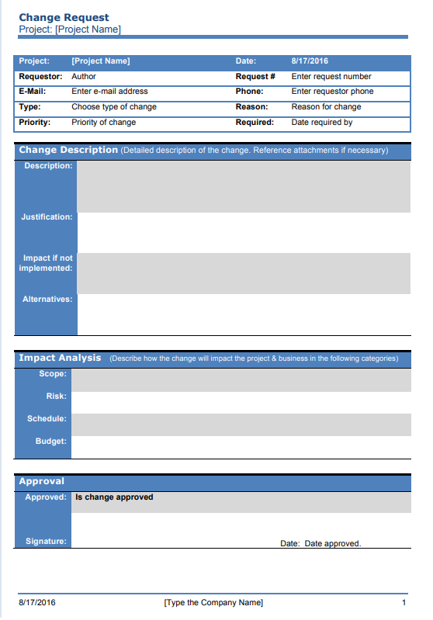

Figure 5. Change Request Form

6.7 Communications Management Plan
This management plan ensures clear, timely, and consistent communication among all project stakeholders involved in the MOTO: Mobile Operations and Tricycle Organizer. For the TODA modernization project, the plan outlines the communication strategy, channels, frequency, and procedures to maintain alignment between TODA officers, tricycle drivers, passengers, and the development team (ByteSize). Effective communication will support transparency, smooth coordination, trust-building, and successful project implementation.
Communication Matrix
This table identifies who communicates with whom, how often, through what medium, and for what purpose. It ensures timely and appropriate communication across all project participants.

Table 33. Communication Matrix
Stakeholder | Purpose | Communication Type | Frequency
Project Sponsor | Review deliverables, approve schedule changes | Messenger / Face-to-Face | Per milestone
Project Team | Task updates, bug reporting | Messenger / MS Teams / Face-to-Face | Daily
Project Adviser | Progress check, review outputs | MS Teams / Face-to-Face | Weekly
Project Consultant | Progress check, review outputs | MS Teams / Face-to-Face | Weekly
Communications Management Approach
- Communication Channels: Facebook Messenger, in-person meetings, and MS Teams.
Stakeholder Matrix
This table identifies who are the stakeholders and their role and responsibilities in influencing to improve the project’s alignment with the stakeholders’ goals with their guidelines to laid out the information appropriate. It ensures that each team member and stakeholder understand their function in project execution and communication.

Table 34. Stakeholder Matrix
Stakeholder | Name | Description
Project Sponsor | Reynaldo Pineda | Provides financial resources, support for the project, and feedback for the project.
Project Adviser | Warren Panizales | Offers academic guideline to ensure the project follows university standards and policies
Project Consultant | Renan Bacit | Offers expert advice on technical aspects of the project. Helps optimize design and execution.
Project Team | Djanairah Benito  Eulan Miguel Capawing  Jerycho Roniel Choa  Ken Aixroch Zamodio | Responsible for the execution of the project deliverables and tasks. Includes developers, designers, testers, and writers.
End User | Passengers | Target audience of the project. Their needs and feedback help the project requirements to achieve and align with success criteria.

Communication Methods and Technologies
To support alignment and collaboration, the following tools will be used:
- Email: Official updates, submission of deliverables, milestone approvals
- Messenger / MS Teams: Day-to-day coordination, task updates
- Face-to-Face: Progress check-ins, adviser consultations
- Google Drive: Centralized file storage and document sharing
Communication Standards
- Maintain a respectful and professional tone in all exchanges
- Respond to emails and inquiries within 24–48 hours
- Escalate urgent issues directly to the Project Manager via Messenger or MS Teams
- Archive official communications via email or Google Drive
- Use version-controlled filenames for documents and spreadsheets
Communication Escalation Process
This process outlines how issues, risks, or concerns are escalated when they cannot be resolved at the current level of authority or responsibility. This ensures timely decision-making, accountability, and project continuity. And the critical issues are addressed promptly and appropriately.

Table 35. Communication Escalation Process
Issue Type | Initial Contact | Escalate to | Resolution Timeframe
Technical Issue | Project Manager | Project Consultant | Within 1 business day
Academic Issue | Project Manager | Project Adviser | Within 1 business day
Budget/Timeline Issue | Project Manager | Project Sponsor | Within 1 business day

6.8 Quality Management Plan
The purpose of this Quality Management Plan is to ensure that the MOTO system consistently meets defined standards of performance, usability, security, and reliability. It aims to deliver a high-quality experience for TODA drivers, passengers, and officers, while supporting the digital transformation goals of Cielito Homes TODA (CCCH TODA).
Quality Objectives
- Ensure transparent and accurate contribution (butaw) tracking through the RFID-enabled Smart Piggy Bank with LCD display.
- Guarantee fast and reliable passenger booking through the mobile app and a booking system.
- Maintain data privacy and security in compliance with the Data Privacy Act (RA 10173).
- Provide an intuitive mobile interface for both drivers and passengers, even for non-tech-savvy users.
- Minimize downtime to support daily TODA operations effectively.

Quality Standards and Performance Levels
- Mobile app and IoT integration must perform reliably in both online and offline conditions.
- All savings, booking, and transaction records must be consistent, accurate, and retrievable.
- The system should remain responsive and scalable to handle growing TODA operations.
Quality Guidelines and Compliance
- Compliance with Philippine Data Privacy Act (RA 10173) as the system must protect all personal and financial information collected from drivers, passengers, and TODA officials.
- Follow secure coding practices and role-based access control for sensitive financial and user data.
- Hardware (Smart Piggy Bank and RFID Scanner) must be durable, tamper-resistant, and field-tested under local CCCH TODA station conditions.
Quality Assurance Activities
- Conduct unit testing, system integration testing, and user acceptance testing (UAT).
- Regularly evaluate system response times and IoT reliability under varying network conditions.
- Collect feedback from TODA officers, drivers, and passengers during pilot testing.
- Apply continuous improvements based on user feedback and performance monitoring.

Quality Metrics

Table 36. Quality Metrics
Metric | Target
Issue Resolution | ≥ 70% of user-reported issues resolved within working 3 days
Form Response Time | ≤ 3 seconds (max 6 seconds on slow networks)
IoT Component Response Time | ≤ 20 seconds (max 35 seconds on low signal)
System Uptime | ≥ 80% during operational hours
User Satisfaction | ≥ 80% based on post-launch feedback

Feedback and Continuous Improvement
The development team will establish regular feedback loops with TODA officers and drivers to identify issues and prioritize improvements. Quarterly reviews will assess system performance and user satisfaction, ensuring that the MOTO system evolves to meet the operational needs of TODA and continues to provide sustainable, high-quality service.

6.9 Risk Management Plan
The purpose of this Risk Management Plan is to identify and manage potential risks that may affect the successful and effective implementation of the MOTO project in Cielito Homes, Barangay 177. Risks were identified through brainstorming sessions with TODA officers, group members, and consultations with the project adviser.
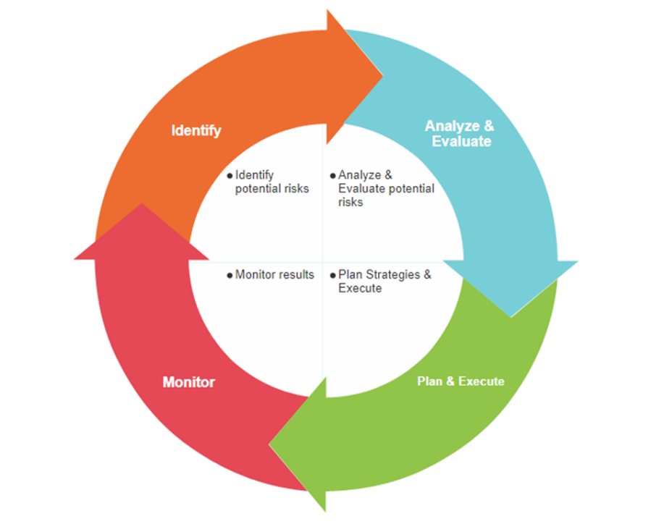

Figure 7. Risk Management Process Cycle
- Identify: Risks and threats that may impact the project’s objectives and goals.
- Analyze: Evaluate the scope and potential impact of risks on overall success.
- Plan & Mitigate: Develop strategies and allocate resources efficiently to reduce risks, including having backup plans.
- Monitor: Continuously track progress and performance to ensure mitigation plans are working, while spotting new risks early.
Risk Identification
Risk identification systematically recognizes potential project issues that may impact objectives, schedules, or deliverables. It allows the team to proactively prepare for threats before they escalate, improving planning, reducing surprises, and ensuring mitigation strategies are in place.

Table 37. Risk Identification
Risk Source | If (Cause) | Then (Effect) | Impact
Planning | The project timeline is unrealistic or does not include enough time for IoT setup (RFID piggy bank with LCD system) and mobile app integration. | Tasks may overrun, leading to schedule slippage. | Delayed completion and increased project costs
Requirements & Design | The initial system requirements (booking, chat support, contribution tracking) are incomplete or unclear. | Major design revisions may be needed during development. | Timeline disruptions and rework costs
Project Team | The team lacks expertise in IoT hardware integration or mobile app deployment. | The quality of deliverables may suffer due to incorrect implementation. | Substandard output and risk of project failure
Stakeholder Management | TODA officers and drivers are not properly trained on how to use the app, piggy bank | Expectations may not be met, leading to low system adoption. | Dissatisfaction, resistance to change, pushback
Users | Driver and passenger requirements are not accurately gathered or validated (e.g., 1.5 km radius for special bookings). | The deployed system may not meet actual community needs. | Poor user experience and limited usage
Technology/  Hardware | IoT components (RFID sensors, LCD display, RFID Scanner) malfunction or fail in real operations. | Contribution and booking data may not sync properly with the mobile app. | Reduced system reliability and trust
Connectivity | Internet/mobile data is unstable at the tricycle station. | Real-time booking updates or savings sync may be delayed or fail. | Passenger dissatisfaction and lost bookings
*Refer to Table 9. Risks for more details.
Risk Responses
- Avoid
  - R3: Implement strong cybersecurity measures (e.g., data encryption, password policies, role-based access) to protect sensitive financial and booking data.
- Transfer
  - Consider a warranty and maintenance agreement with IoT hardware suppliers (smart piggy bank sensors and RFID scanner) to cover malfunctions or early failures.
- Mitigate
  - Ensure regular system testing, operator training, awareness drives for drivers and passengers, and early procurement of IoT hardware to prevent delays (R1, R2, R4, R5, R7).
- Accept
  - Monitor budget-related risks (R6) and prepare contingency funds for minor overruns related to IoT device replacements or software updates.
Risk Register
By proactively managing project risks, risk registers help teams foresee possible obstacles, lessen adverse effects, and increase the chances of project success. The risk scenarios that the team could face throughout the project's development and lifecycle are depicted here.

Table 38. Risk Register
Risk ID | Risk Description | Probability | Impact | Risk Owner | Response Strategy
R1 | Delays in delivery or installation of IoT devices (piggy bank) | Medium | High | Project Manager | Mitigate: Order early and identify alternative suppliers if needed.
R2 | Technical malfunctions in piggy bank system after deployment | High | High | IT Developer | Mitigate: Conduct thorough hardware and app integration testing; have on-call tech support.
R3 | Data privacy breaches or unauthorized access to contribution/booking data | Low | High | System Admin | Avoid: Use encryption, secure login protocols, and role-based access control.
R4 | Low adoption by drivers or passengers due to lack of awareness/training | Medium | Medium | TODA Chairperson/Operator | Mitigate: Conduct onboarding sessions, awareness campaigns, and simple user guides.
R5 | Insufficient internet connection affecting savings sync or booking system | High | Medium | Station Operator / IT Lead | Mitigate: Enable offline queue caching and use backup LTE/mobile data.
R6 | Resistance from drivers or operators to shift from manual to digital workflow | Medium | Medium | Project Lead | Mitigate: Conduct orientations highlighting benefits; emphasize transparency and fairness.
R7 | Misuse or damage of hardware (piggy bank) due to daily handling | Medium | Medium | TODA Operator | Mitigate: Provide basic handling training; set warranty/maintenance agreements.
Qualitative Analysis:
- High Impact Risks: R1, R2, R3
- Medium Impact Risks: R4, R5, R6, R7
- Low Impact Risks: None
Quantitative Examples:
- R1: A 1-week hardware delivery delay could push the project launch back by up to 15% of the timeline.
- R2: Unresolved technical failures could result in 30% downtime, reducing bookings and contribution tracking reliability.
- R5: Poor connectivity could delay contribution logging by 10–15 minutes, affecting trust and adoption.
Monitor and Reassess
- Conduct weekly team meetings during project development and pilot deployment.
- Maintain a risk tracking sheet to update the risk register and adjust mitigation strategies.
- Perform reassessments at project milestones (e.g., post-installation, training, and pilot testing).
- Assign responsibility to project leads and TODA operators to monitor and report on active risks.
Risk Reporting Form
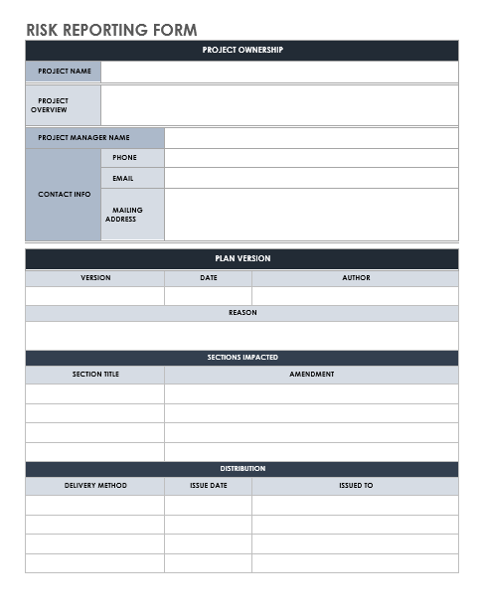

Figure 8. Risk Reporting Form

6.10 Procurement Management Plan
The purpose of this Procurement Management Plan is to define the processes for acquiring all goods, services, and resources necessary for the successful implementation of the MOTO project in Cielito Homes TODA, Barangay 177.

Table 39. Procurement Plan
Category | Item | Source | Qty | Estimated Cost (₱) | Responsible Person | Target Date
Hardware | Allan Universal Coin Slot | MakerLabs | 1 Set | ₱500 | Choa, Jerycho Roniel,  Zamodio, Ken Aixroch, and Capawing, Eulan Miguel | Before September 2025
Hardware | RFID Cards/Tags (Driver IDs) | MakerLabs | 1 Set | ₱300 |  | Before September 2025
Hardware | ESP32 Development Boards | MakerLabs | 1 pc | ₱360 |  | Before September 2025
Hardware | LM2596 DC-DC Module | MakerLabs | 1 pc | ₱95 |  | Before September 2025
Hardware | RC522 RFID Reader and Scanner | MakerLabs | 1 pc | ₱130 |  | Before November 2025
Hardware | Power Switch | Local Shop | 1 pc | ₱49 |  | Before September 2025
Software | Mobile App Development Tools (Android Studio, Firebase) | Free / Licensed Tools | 1 Set | ₱0 (open source) |  | Before September 2025
Software | Realtime Database, Cloud Hosting, and Cloud Storage | Google | 1 year | ₱3,720 |  | Before September 2025
Miscellaneous | Jumper wires and Breadboard | MakerLabs | 1 Set | ₱110 |  | Before September 2025
Documents | Training & Documents (User Manuals and ID printing) | Local Printing Shop | 1 set | ₱114 | Benito, Djanairah | Before October 2025
All items will be procured on a fixed-price basis to control costs and budgeting.
Primary Sources for Procurement:
- MakerLabs Philippines – For IoT and electronic components such as ESP32 boards, RFID sensors and scanners, LM2396 modules, and LCD displays.
- Shopee (Local Tech Sellers) – For accessories such as cables, prototyping materials, power supplies, and backup batteries.
- Cloud Hosting Providers (Firebase and Google Cloud) – For database, mobile app hosting, and system deployment needs.
- Local Printing Shops – For TODA training manuals, flyers, and orientation materials.
Evaluation Criteria for Supplier Selection:
- Product affordability and availability for IoT components and hardware.
- Seller ratings and customer reviews (especially for Shopee suppliers).
- Warranty, after sales support, and return policies for sensitive components (e.g., RFID readers, and sensors).
- Delivery timeline and shipping reliability to avoid deployment delays.
Supplier Selection Process:
- Gather quotations from MakerLabs, Shopee sellers, and cloud hosting providers.
- Compare technical specifications and pricing for IoT hardware (RFID with scanners, LCD, piggy bank sensors).
- Use a supplier evaluation matrix based on cost, quality, warranty, and delivery speed.
- Final decision made by the Project Team in coordination with TODA leadership to ensure alignment with budget and operational needs.
Roles and Responsibilities

Table 40. Roles and Responsibilities for Procurement
Roles | Responsibility
Project Manager | Ensures that the procurement tasks are feasible and makes sure everything is on track and schedule. This includes the expenses needed.
Project Advisor | Gives advice to help with procurement decisions with regards to the expenses and strategic approach to have an efficient procurement of items
Project Consultant | Gives recommendation especially with regards with the technical needs such as the hardware and software.
Project Sponsor | Approves the budget and supports project team’s decisions.

6.11 Implementation Plan
The implementation plan for the MOTO system outlines how the project will be developed, deployed, and transitioned to ensure it supports TODA operations with rapid adoption, stability, and transparency. The system components include the mobile application (driver and passenger sides), IoT hardware (RFID-Based Smart Piggy Bank), and cloud-based backend services will be developed and tested in phases to allow modular deployment and efficient troubleshooting.
The project will follow an Agile methodology, enabling iterative development, continuous testing, and feedback-driven improvements. This approach ensures that TODA officers, drivers, and passengers can gradually adapt to the new system while minimizing risks of adoption resistance.
Rollout Plan
The rollout plan divides the implementation of the MOTO system into five (5) key phases, each with clear tasks, responsibilities, and success criteria:

Table 41. Rollout Plan
Steps | Task | Description | Responsible | Success Criteria
Phase 1: System Design | Hardware Procurement | Design database, hardware integration, and IoT structure | Hardware Engineer | All components are delivered and tested
Phase 1: System Design | System Design | Draft passenger, driver, and admin dashboard UI/UX | UI/UX Designer | Finalized and analyzed system design
Phase 2: System Development | Install IoT components | Assemble and integrate RFID-enabled piggy bank system with backend. | Hardware Engineer | Modules data stored and updates on the system
Phase 2: System Development | Software Development and Finalization | Develop mobile application and admin dashboard. Integrate IoT hardware with backend. | Software Developer, Hardware Engineer | Modules and system can function with each other
Phase 3: System Testing | System Beta Launch | Evaluate performance, security, and data integrity | Software Developer, Hardware Engineer, QA Tester | Ensure the system is functioning and running well
Phase 3: System Testing | Collect Feedback | Conduct beta testing and collect feedback | Project Team (All members) | Feedback collected and analyzed
Phase 4: System Deployment | Device Installation | Install RFID piggy bank and RFID scanner at CCCH TODA station. | Hardware Engineer | The device is safe, and modules are collecting data accurate
Phase 4: System Deployment | Launch MOTO System | Open and launch the system to the public access | Software Developer | No critical bugs reported
Phase 4: System Deployment | Staff Training | Conduct training for TODA officials and drivers on usage of piggy bank, booking module, and app. | Project Manager | TODA officials and drivers understand and adapt how the system works
Phase 5: Post-System Development | System Bugs Reported | Check and address all the software/hardware bugs | Project Manager, QA Tester | Addressed all the new bugs reported
Phase 5: Post-System Development | Monitor System Performance | Check and track uptime and implement improvements | Software Developer, Hardware Engineer | >90% uptime, no critical failures and bugs reported
Phase 5: Post-System Development | System Finalization and Handover | Present and handover the final project | Project Team (All members) | Client obtains the system with no issues
Training and Support
Training Topics:
- Operation of RFID-Enabled Smart Piggy Bank – How to record and verify driver butaw contributions using assigned RFID cards.
- RFID Assignment Procedure – Admin training on assigning RFID UIDs to verified drivers and managing RFID distribution in person.
- Admin Dashboard Usage – Using the web dashboard (requires laptop or tablet) to monitor driver registrations, verify IDs for discounts, manage bookings and queues, track contributions, and view audit logs.
- Mobile Application Usage – Navigating the driver, passenger, and barker apps for booking, butaw tracking, and communication.
- Troubleshooting Common Issues – Addressing common errors in the mobile apps, RFID hardware syncing, or dashboard connectivity.
- Privacy and Security Compliance – Training on proper handling of personal data, ID verification, and contribution records under the Data Privacy Act of 2012 (RA 10173).
During driver orientation, it will be emphasized that all butaw contributions are final once logged in the Smart Piggy Bank. This ensures fairness, prevents disputes, and maintains the integrity of the contribution system.
Support Materials:
- Training manuals and quick-reference guides tailored for drivers, passengers, and TODA officers.
- Video tutorials for navigating the mobile app (driver and passenger side) and using the dashboard.
- Dedicated chat support/email line for reporting technical issues or requesting assistance.
Sustainability:
- Designate 1–2 TODA tech support liaisons responsible for ongoing system assistance and coordination with the development team.
- Service Fee Handling: During the initial implementation, the ₱2 convenience fee for app-based bookings will be temporarily collected with the fare in cash and remitted to the platform administrator through the TODA association or operator. In future updates, once digital payment systems (e.g., GCash, Maya) are integrated, this fee will be automatically separated and processed digitally to ensure accuracy, transparency, and compliance with local transport regulations.

Operational Handover
Upon full deployment:
- Turnover system credentials to the TODA president
- Provide documentation including:
  - Source code and server access
  - Admin guides and Maintenance schedule
- Issue a formal handover letter signed by the project lead and TODA chairperson, signifying project transition.
Post Implementation Review
After two months of full implementation:
- Conduct a review meeting with TODA officials, selected drivers, passengers, barkers, and the ByteSize development team.
- Evaluate system performance and adoption based on:
  - Number of RFID-linked contributions successfully logged
  - Number of completed bookings (onsite and online)
  - Verified discount ID approvals
- Feedback on usability, efficiency, and satisfaction
- Document all lessons learned, feature requests (e.g., digital payments, analytics expansion), and recommendations for scaling to other TODAs or improving existing functionalities.

7.0 Sponsor Acceptance
Project Title: “MOTO: Mobile Operations and Tricycle Organizer for Cielito Cristina Castle Spring Heights TODA Efficiency"
Project Manager: Djanairah M. Benito
Project Sponsor: Reynaldo Pineda
Date: August 5, 2025
Project Overview
The MOTO: Mobile Operations and Tricycle Organizer is a digitalization project for the Cielito Homes TODA (Barangay 177) that integrates IoT hardware and mobile technology to streamline contribution tracking, booking, and operational management. It features an RFID-enabled Smart Piggy Bank with LCD display that allows verified drivers to log their daily butaw contributions digitally, automatically syncing records to the admin dashboard for transparency. The system also includes a queueing and booking platform that manages both onsite (walk-in) and online (app-based) rides, supporting fair dispatching and efficient service flow. Passengers can book rides, upload valid IDs for verified fare discounts, and communicate with drivers through in-app chat. Meanwhile, TODA officials use a web-based admin dashboard (accessible via laptop or tablet) to manage RFID assignments, verify documents, monitor contributions, and track booking activities. By digitizing manual processes, MOTO enhances fairness, accountability, and efficiency in TODA operations, driving the organization’s shift toward transparent, technology-driven transportation management within a four-month development cycle (July–October 2025).
Deliverables Summary
Table 10. Project Deliverables
Deliverable | Description | Status | Expected Date
Project Plan Document | Complete documentation including business case, scope, schedule, and budget. | On-going | August 28, 2025
MOTO System Design | Contains the design of the user interface and the included features | On-going | September 4, 2025
Piggy Bank and Two-Button Integration | Hardware components installed and integrated | On-going | September 25, 2025
Piggy Bank and Two-Button Device | Contains the application with functional unit device | On-going | October 1, 2025
System Testing & QA Feedback | Testing by barangay staff and residents for feedback | To be started | October 15, 2025
Training Materials | Documentation to guide both TODA officials and tricycle drivers on using the system. | To be started | October 18, 2025
Final Project Report & Documentation | Project report, user manuals, and training materials | To be started | October 31, 2025

Acceptance Criteria

The MOTO: Mobile Operation and Tricycle Organizer system will be considered accepted by stakeholders upon successful fulfillment of the following measurable criteria:

Table 42. Acceptance Criteria
Criteria | Description
Functional Completion | The system must perform all core functions, including RFID-based butaw contribution tracking via the smart piggy bank with LCD, two-button booking operations (red for regular station queue, green for special app-based bookings), mobile app booking within the 1.5 km radius, and admin dashboard monitoring. All components must operate as intended.
User Interface Usability | The mobile app must be accessible, intuitive, and functional across all user roles (driver, passenger, admin). Usability must be validated through pilot testing with CCCH TODA drivers, passengers, and officials.
System Stability | The system should remain stable and responsive (no crashes or critical bugs) during testing, even with multiple concurrent users booking rides or logging contributions.
Data Accuracy & Storage | All contribution logs, booking records, and trip data must be securely stored, retrievable, and reflect actual input values with at least 90% accuracy.
Security Compliance | User information and financial records must comply with the Data Privacy Act (RA 10173), with encryption, role-based access control, and secure consent flows.
Deployment Readiness | IoT hardware (RFID piggy bank, LCD display, two-button booking system) must be fully installed and operational at the CCCH TODA station. Network connectivity and offline fallback (e.g., queue saving) must be verified.
Stakeholder Satisfaction | CCCH TODA officials, drivers, and passengers must confirm that the project goals have been met during final review and pilot testing.
Documentation Provided | Complete user manuals, system documentation, and maintenance instructions must be submitted for drivers, passengers, and TODA officials.

List of Tables
Table: 1 Work Breakdown Structure 10
Table 2. Cost Analysis 14
Table 3. Reference table of the links 15
Table 4. Benefit Analysis 15
Table 5. Success Criteria 27
Table 6. Quality, Time, and Cost Benchmarks 27
Table 7. Functional Requirements 28
Table 8. Non-Functional Requirements 29
Table 9. Risk 33
Table 10. Project Deliverables 34
Table 11. Summary Milestone Schedule 35
Table 12. Budget Summary 35
Table 13. Approval Criteria 37
Table 14. Names of Approving Authorities 37
Table 15. Tools and Software 41
Table 16. Roles and Responsibilities 41
Table 17. Stakeholder Identification 51
Table 18. Stakeholder Analysis 51
Table 19. Engagement Plan 52
Table 20. Bottom-Up Estimation for Labor 56
Table 21. Bottom-Up Estimation for Hardware 56
Table 22. Bottom-Up Estimation for Software 57
Table 23. Bottom-Up Estimation for Training and Documents 57
Table 24. Bottom-Up Estimation for Operation and Maintenance 57
Table 25. Bottom-Up Estimation for Miscellaneous and Contingency 57
Table 26. Work Breakdown Structure 59
Table 27. Three-Point Estimation 61
Table 28. Task Dependencies 62
Table 29. Staffing Management Plan 63
Table 30. RACI Chart 64
Table 31. Roles and Responsibilities for Change Control Board 66
Table 32. Change Control Board (CCB) 66
Table 33. Communication Matrix 68
Table 34. Stakeholder Matrix 68
Table 35. Communication Escalation Process 70
Table 36. Quality Metrics 71
Table 37. Risk Identification 73
Table 38. Risk Register 74
Table 39. Procurement Plan 77
Table 40. Roles and Responsibilities for Procurement 78
Table 41. Rollout Plan 79
Table 42. Acceptance Criteria 84

List of Figures
Figure 1. Cielito Homes Tricycle Station 3
Figure 2. Tricycle Fare Matrix 24
Figure 2. Signed Approval Letter 38
Figure 3. Agile Methodology 39
Figure 4. MOTO System Architecture Diagram 48
Figure 5. Change Request Form 67
Figure 7. Risk Management Process Cycle 72
Figure 8. Risk Reporting Form 76

8.0 Appendices

References
[1] Just a moment... (n.d.). National Privacy Commission National Privacy Commission. https://privacy.gov.ph/data-privacy-act

